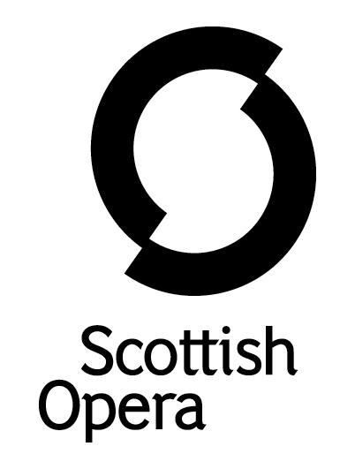

Press Release

16 APRIL 2021

SCOTTISH OPERA CELEBRATES LOCAL VENUES WITH A FILM FROM RUTHERGLEN TOWN HALL

Scottish Opera premieres Live in South Lanarkshire in the latest Scottish Opera: On Screen, filmed at Rutherglen Town Hall on 24 March 2021.

The Company’s Opera Highlights production at Rutherglen Town Hall in March 2020 was the last time there was an audience in the theatre, before the pandemic forced venues to close their doors. Therefore, Scottish Opera are especially delighted to be given the key to Rutherglen Town Hall for this special film, to take advantage of the stunning surroundings in a celebration of local venues, encouraging communities to return as soon as Scottish Government guidelines allow. Created in association with South Lanarkshire Culture and Leisure, this film of operatic favourites will be available to watch from 23 April on Scottish Opera’s website.

Scottish Opera’s Head of Music Derek Clark is joined by Emerging Artists Margo Arsane and Catriona Hewitson for a playlist of well-known opera hits including Delibes’ ‘Flower Duet’ – the much-loved soundtrack to British Airways' TV adverts – and Puccini’s ‘O mio babbino caro’ – familiar from TV and films including the Merchant Ivory classic A Room with a View. Along with an introduction from Rutherglen Town Hall’s Venue Manager, Colin McWilliams, Emerging Artists Catriona Hewitson and Margo Arsane share their experiences of being opera singers and we hear from Derek Clark about how he was introduced to opera, and what makes the art-form so special.

Scottish Opera’s General Director, Alex Reedijk said: ‘We are grateful to South Lanarkshire Culture and Leisure for their support on this project which gives our talented Emerging Artists the opportunity to perform. It has been over a year since we last visited the Rutherglen Town Hall with our Opera Highlights tour, for what was also our last live performance for a Scottish audience in a theatre before the pandemic. So, in response to this, we wanted to create something which celebrates the incredible local venues and all that they do for Scottish Opera and their communities. We are really looking forward to being able to perform indoors for audiences again soon, and in the meantime we hope you enjoy our film.’

Rutherglen Town Hall Venue Manager, Colin McWilliams, said: ‘This is the first project we’ve had since we went into lockdown a year ago. Ironically, the last performance we had at the town hall was Scottish Opera with their Opera Highlights show. It was a fantastically successful night which sold out, but, little did we know what was round the corner. Fortunately, now, thanks to funding from Creative Scotland, we’re able to put on projects such as this, and welcome Scottish Opera back in – a year later – to what will no doubt be a fantastic film.'
Available to watch online via www.scottishopera.org.uk from 23 April.

Notes to Editors
Live in South Lanarkshire was produced in line with Scottish Government guidelines in place at the time of filming.
The Company’s Opera on Screen productions are available to watch at www.scottishopera.org.uk/what-s-on/opera-on-screen/.
The collection includes Humperdinck’s Hansel and Gretel, Mozart’s Così fan tutte, Opera Highlights, Janáček’s The Diary of One Who Disappeared, Menotti’s The Telephone and Samuel Bordoli and Jenni Fagan’s The Narcissistic Fish.

Scottish Opera is Scotland’s national opera company and the largest performing arts organisation in Scotland.
The Company's performance repertoire ranges across five centuries, from the earliest operas to newly-commissioned world premieres, working in collaboration with the world's finest singers and creatives, alongside The Orchestra of Scottish Opera and choruses. Recent accolades include a South Bank Sky Arts Award, a Scottish Award for New Music, Sunday Herald Culture Awards and a Herald Angel, as well as a 2020 RPS Award nomination.
Scottish Opera's work caters for audiences of all ages – ranging from babies to people living with dementia – and our Young Company and Emerging Artist programme support the talent of the future.
The Company tours extensively across Scotland, from the largest-scale theatres to rural venues with a capacity as low as 22, to ensure we are within reach of as many of our country's very dispersed population as possible. A miniature mobile opera house – literally, opera performed inside a converted 40-foot-long trailer on the back of a lorry – brings ‘Pop-up Opera’ performances to thousands of people each year in a range of inspiring and unexpected community locations. This represents the most extensive touring programme of any opera company in Europe and is a much-valued contribution to Scotland’s cultural and artistic life, particularly in remote and island communities.
The Company’s Education and Outreach programme, which celebrates 50 years in 2021, includes an annual Primary Schools Tour, bringing upper primary-aged children the opportunity to perform their own specially-commissioned piece, alongside three professional singers. Around 120 schools and 9,000 pupils take part each year.
Scottish Opera aims to be inclusive and affordable through availability of free and cheap tickets, as well as access performances including audio description, and performances which cater to those living with Dementia.
In the year to 31 March 2020, 116,960 people experienced Scottish Opera as audience members or as participants, across all of Scotland’s 32 Local Authority areas:
• 56 mainstage opera performances in Scotland plus tours to Belfast, London and Australia
• 8% of ticket buyers for mainstage opera performances in Scotland aged under 26
• 2,422 people watched specially-created opera productions for babies or toddlers
• 40,177 people participated in school’s workshops and performances
• 1,123 people living with Dementia participated in projects.

Scottish Opera is core funded by The Scottish Government

For additional press details please contact:
Julie McLaughlin, Press Officer, 0141 242 0552, julie.mclaughlin@scottishopera.org.uk

