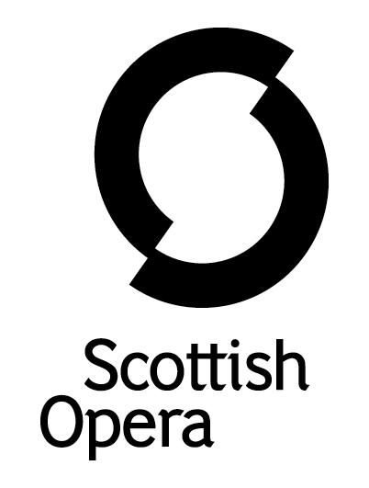
RECRUITMENT DIVERSITY MONITORING FORM

Scottish Opera is committed to providing fair and equal access to opportunities in employment. The Equality Act 2010 protects people from discrimination and promotes equality on the basis of a number of ‘protected characteristics’. We ask for information about your ‘protected characteristics’ in order to help us monitor our performance on equality. Our policy also aims to make sure that candidates are not disadvantaged by job qualifications and requirements, which are not justified by the nature of the post.

The information you provide will be treated as strictly confidential and will be used only for recruitment diversity monitoring purposes. The information will not be used at any stage of the selection process.

Post applied for:
First name: |  | Surname:

[Please tick or highlight your answer for each category]

- Gender Male  Female 

- Are you married or in a civil partnership? Yes  No 

- What age group are you in?

16 – 25  | 26 – 30  | 31 – 40  | 41 – 50 
51 – 60  | 61 – 65  | 66+ 

- How would you describe your national identity?

British  English  Irish  Scottish  Welsh 
If another nationality, please specify this

- Ethnicity

Asian – Asian Scottish or Asian British  | Black, Black Scottish or Black British 
Mixed / multiple ethnic group  | White – British, English, Irish, Scottish, Welsh 
Other ethnic group  | Please specify

6. Do you consider yourself to be disabled? Yes  No 

[A disability is considered to be an impairment that has a substantial and long-term adverse effect on the ability to carry out normal day-to-day activities]

In relation to access and facilities, do you have any special needs, which may require special provisions for either attendance at the interview or in the work place?
Yes  No 

If yes, please give details

- What is your sexual orientation?

Bisexual  | Gay man  | Gay woman/lesbian  | Heterosexual/straight 

- What is your religion or belief?

Buddhist  | Christian  | Hindu  | Jewish 
Muslim  | No religion  | Sikh  | Any other 

Thank you, by completing this form you have helped us better understand how we, as an employer, can ensure equality of opportunity for all.

Scottish Opera strives to be an equal opportunities employer and is subsidised by the Scottish Government.

Scottish Opera
39 Elmbank Crescent, Glasgow, G2 4PT
Telephone: 0141 248 4567 Fax: 0141 221 8812

