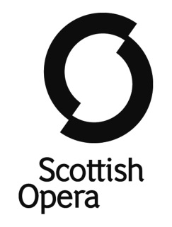

SCOTTISH OPERA CONNECT CHORUS APPLICATION FORM

Before completing the application form, please check that you are available from Monday 9 to Saturday 14 July 2018 for our Connect Gateway Course. Please ensure that you clearly state your telephone number and email address as we will use this information to contact you about your audition date and time. Please also attach a recent passport sized photograph or a scanned in photograph of yourself to the application form.

You must also be available for auditions in Glasgow on Saturday 3 March 2018, during one of the time slots below. The session will be made up of a drama workshop and your singing audition. You will be asked to present two contrasting pieces, one of which must have piano accompaniment. You may bring your own pianist, however a Scottish Opera pianist will also be available on the day. Please tick to confirm your availability:

Auditions – please offer both slots if you are able. Preference will be taken into consideration if possible.

Saturday 3 March 2018 (10.30am – 1.30pm) □

Saturday 3 March 2018 (2.30pm – 5.30pm) □

Please complete this application fully to give us an idea of your experience, voice type and reasons for applying:

Name |  | Date of birth
Home address

Telephone number and mobile number |  | Email address
Voice type

Name of school/college (if applicable) | Name of music/singing teacher (if applicable)
Have you ever been to see a live opera? YES/NO
If YES, please tell us your thoughts on the experience.
If NO, is there any particular reason? If so, please give details

Please give details of any performance residencies, workshop projects or amateur musical groups you are currently a member of or have been involved with in the past:

Personal statement
Why do you want to take part in Connect and what do you hope to gain from the experience? (Please continue on a separate sheet if necessary)

Reference
Please provide details of a relevant referee. Your chosen referee should be able to comment on your suitability for Connect Chorus including your commitment, reliability and singing ability.

The fee for Connect Gateway Week 2018 is £200. Payment can be made in instalments, in consultation with Scottish Opera. No student who successfully auditions for Connect will miss out due to financial circumstances. We can also offer travel bursaries to those who need financial help getting to auditions and rehearsals in Glasgow.

Please indicate by ticking here if you would like more information about funding and bursaries. □

Completed application forms should be returned to Iona Jack at the address below no later than Wednesday 31st January 2018.

Iona Jack, Scottish Opera, 39 Elmbank Crescent, Glasgow G2 4PT
If you have any queries please contact Iona on 0141 242 0585 or iona.jack@scottishopera.org.uk

