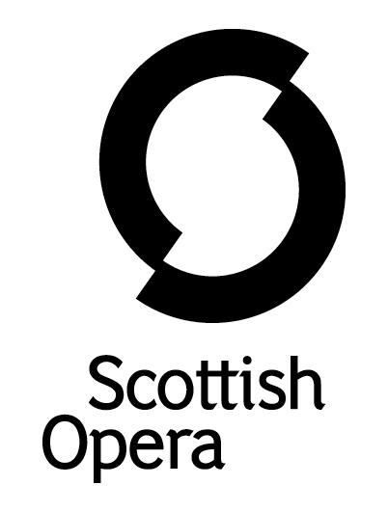

Press Release

14 November 2018

SCOTTISH OPERA CELEBRATES CENTENARY OF THE ROYAL AIR FORCE WITH UNIQUE PROJECT
FROM THE MUD TO THE STARS

Scottish Opera is celebrating 100 years of the Royal Air Force with a unique project called From the Mud to the Stars.

The project launched in October 2017 and since then a team from Scottish Opera, including former Emerging Artist Andrew McTaggart, has been working with school pupils, students, and former and serving RAF personnel to gather thoughts and impressions of the past, present and future of the Royal Air Force.

Over 250 people in communities all over Scotland, ranging in age from five to 103 who have special connections to the RAF, have participated in a range of From the Mud to the Stars workshops involving singing, song writing, visual arts and creative writing.

From the Mud to the Stars learning resources are now available on Scottish Opera’s website and are free to anyone wishing to learn more about the RAF. These include short films, music, art and design and literacy activities specially created by Scottish Opera and designed to meet specific Curriculum for Excellence outcomes. These songs, poetry, prose and visual images reflect the memories and experiences of those connected to the RAF, from the mud of the trenches to the advanced technology of 21st century flight.

The eight short films entitled ‘RAF Lives’ feature people from different generations, all of whom have or have had, a connection to the Royal Air Force, covering topics including bringing up a family, career paths and the experience of fighting during World War II.

Matthew Brown has composed the project’s theme tune entitled From the Mud to the Stars (loosely based on the RAF motto ‘Per Ardua Ad Astra’, meaning ‘Through adversity to the stars’) with lyrics by Ross Stenhouse. Another original piece of music entitled Silver Wings inspires participants to write their own short dramas. Other activities in the project include designing RAF recruitment posters, writing a play with an aeronautical theme and creating a wall frieze that celebrates the rich variety of aeroplanes flown by the RAF. There is also a book, film and television bibliography for those wishing to explore the RAF’s history further.

Scottish Opera’s Director of Outreach and Education Jane Davidson said: ‘This project is Scottish Opera’s response to a call from the Scottish Government for creative interpretations of the commemoration of World War I as part of the 14-18 NOW campaign. As our project was scheduled to complete in 2018, we decided to focus on the Royal Air Force, which was also commemorating its centenary in the same year.

‘Given that we wanted to pay homage to the fact that the earliest use of air power in World War I was for the purposes of reconnaissance, when pilots flew high over trenches filled with poor infantry soldiers mired deep in the mud, we felt that incorporating both mud and stars in the name aptly reflected aspects of both the old and new types of warfare.

‘As the RAF100 strapline says, the campaign has been designed to ‘commemorate, celebrate and inspire’ and we hope that From the Mud to the Stars will do the same.’

In October, Andrew McTaggart, members of the Scottish Opera Young Company and pupils from Dunblane’s Queen Victoria School and Glasgow’s Jordanhill School performed at the RAF in Concert performance at Glasgow Royal Concert Hall. It formed part of a series of events staged around the UK to commemorate and celebrate the Royal Air Force, and the performers sang a medley which included ‘From the Mud to the Stars’ and ‘Good Old RAF’.

For more details about From the Mud to the Stars, visit www.scottishopera.org.uk/join-in/from-the-mud-to-the-stars

-ENDS-

From the Mud to the Stars creative and performance team

Composer & music animateur Matthew Brown
Singer & vocal animateur Andrew McTaggart
Visual artist & film maker Iain Piercy
Writer Ross Stenhouse

www.scottishopera.org.uk

You can follow Scottish Opera on Twitter, Facebook and Instagram @ScottishOpera

Notes to Editors

Scottish Opera biography
Scottish Opera is Scotland’s national opera company and the largest performing arts organisation in Scotland. It was founded by Alexander Gibson in 1962 and was inaugurated with a production of Madama Butterfly at the King's Theatre in Glasgow.

Notable achievements include the world premiere of James MacMillan's Inés de Castro at the 1996 Edinburgh International Festival; complete Ring cycles at the 2003 Edinburgh International Festival, which won the 2004 South Bank Show Award for Best Opera Production; and the Achievement in Opera Award at the 2017 UK Theatre Awards for Sir David McVicar’s production of Debussy’s Pelléas and Mélisande. Recent commissions include Five:15 Operas Made in Scotland (2008-10); The Lady from the Sea, Clemency, the double bill of In the Locked Room and Ghost Patrol (winner of a South Bank Sky Arts Award) which premiered at the 2012 Edinburgh International Festival and 2016's The Devil Inside by Stuart MacRae and Louise Welsh. Earlier this year the Company made its US debut with BambinO at the Metropolitan Opera New York, and returns to the city’s Brooklyn Academy of Music with Greek in December.

Scottish Opera is committed to bringing the widest possible range of opera, performed to the highest possible standards, to the maximum audience throughout Scotland and the UK. Each year it performs in Glasgow, Edinburgh, Aberdeen and Inverness, as well as smaller theatres, village halls and community centres throughout the country.

Scottish Opera’s Education and Outreach Department was the first of its kind of any opera company in Europe. It operates an extensive programme which involves over 8,000 primary school children every year as well as many other activities including adult learning and Unwrapped taster sessions.

Scottish Opera is supported by the Scottish Government.

For additional press details please contact:
Emily Henderson, Press Manager, 0141 242 0511, emily.henderson@scottishopera.org.uk
Emma Ainley-Walker, Press Officer, 0141 242 0552, emma.ainley-walker@scottishopera.org.uk

