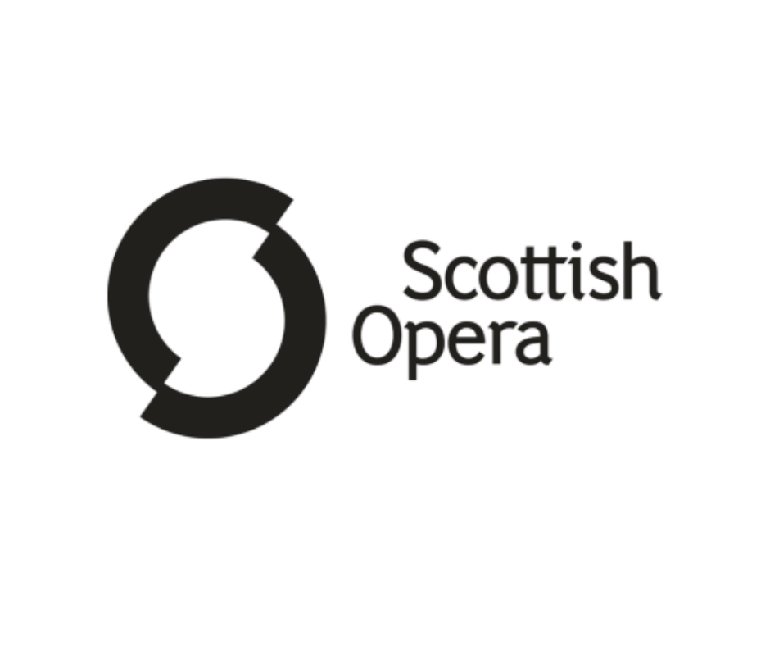

Candidate Pack: Patrons and Fundraising Engagement Manager
Location: Hybrid, with 3 days in Glasgow Head Office (G2 4PT)
Salary: £32,000 - £36,000 per annum
Hours: Full time – 35 hours per week
Closing date: Midnight Monday 20th July

Welcome from Isla Campbell Lupton, Director of Development at Scottish Opera
Thank you for your interest in joining Scottish Opera as our Supporter Engagement Manager.

At Scottish Opera, our mission is to share the power and joy of opera with as many people as possible - from grand stage productions to community projects and education programmes that inspire the next generation. None of this would be possible without the generosity and enthusiasm of our supporters.

The Supporter Engagement Manager role is an existing and valued role within the Development team at Scottish Opera. The role focuses on providing excellent donor experience across our committed supporters, bringing them closer to Scottish Opera and the impact of their support.

I joined Scottish Opera a year ago and have loved it. It’s a varied and rewarding place to work, where fundraising activity is supported by the wider organisation and there is ample space to combine creativity with strategy, and relationship-building with storytelling. No two days are ever quite the same.

You’ll be joining a warm and collaborative organisation where everyone, on stage and off, works together to make world-class opera accessible to all. We don’t expect you to have a background in opera, but if you’re passionate about the arts, this is an exciting and fulfilling place to work.

If you have experience in fundraising, love connecting with people, and want to make a tangible difference, we’d be delighted to hear from you.

Thanks for expressing interest,


Isla Campbell Lupton

Background on Scottish Opera
Scottish Opera’s mission is to entertain, inspire, surprise, educate, challenge, and delight audiences by delivering high quality, powerful, innovative opera throughout Scotland and internationally.
Scottish Opera is Scotland’s national opera company and the largest performing arts organisation in Scotland. The Company was founded in 1962 by Sir Alexander Gibson “to lay the treasures of opera at the feet of the people of Scotland”. The current season marks its 64th Anniversary.
The Company’s productions have won worldwide critical acclaim. Performances range from the earliest operas to world premieres. All mainstage performances, regardless of language, are supertitled. Access (dementia friendly) and audio described performances further widen accessibility to opera. Scottish Opera provides free tickets to asylum seekers, refugees, and school groups and discounted tickets to those under the age of 26. Small-scale tours travel to every corner of the country. Education and Outreach programmes (run by the longest-standing department of its kind in Europe) make opera accessible to all ages, social backgrounds, and abilities, developing personal creativity, interest in opera, and wellbeing.
Scottish Opera is one of five National Performing Companies part funded by the Scottish Government. Government funding increased slightly ahead of this current Season. Fundraising plays an important role in securing income and support from individuals, trusts, and the private sector, alongside income from ticket sales, production hire, and manufacturing.

Scottish Opera’s mission and values

Scottish Opera’s mission
To entertain, inspire, surprise, educate, challenge and delight audiences old and new in delivering high quality opera throughout Scotland, the rest of the UK, and internationally.

Their values
Every day they aim to:
- Achieve excellence in everything: rigorous, discerning, astute, demanding
- Build strong partnerships: imaginative, collaborative, confident, smart, transparent, inclusive
- Reach beyond the comfort zone: courageous, curious, adventurous, leadership
- Work as a team: ambitious, energetic, coherent, respectful, trust, integrity

Context
- A National Performing Company funded directly by the Scottish Government and the only full-time, professional opera company in Scotland
- Scottish Opera attracts significant support from individuals, trusts, and the private sector alongside earned income from ticket sales, production hire, transport, and manufacturing
- Their artistic frame places existing audience favourites next to surprising, less familiar works and new commissions
- The Company regularly gives full-length, fully-staged opera performances and concerts in Glasgow, Edinburgh, Aberdeen and Inverness. It tours to all four corners of the country – from Lerwick and the Western Isles, to Stranraer and Kelso, and everywhere in between
- Scottish Opera contributes significantly to Scotland’s cultural ecology, retaining artists, creatives, artisans, and other performance-related professionals in Scotland through employment and training opportunities
- The Company’s extensive, integrated Outreach and Education programme is for people of all ages, social backgrounds and abilities, contributing to the development of individuals’ personal creativity, interest in opera and health and wellbeing
- Continually dedicated to the support and development of young artists, creatives and artisans

Background on the Patrons and Fundraising Engagement Manager role

Why is this role vacant?
The current post holder has been with Scottish Opera for over six years and is moving on to a new role with a broader remit.
This role sits underneath the Head of Individual Giving, currently a maternity cover with the substantiative post holder due back in early 2027.

The team
Underneath the Director of Development sits
- Trust Fundraising Manager
- Events Manager
- Data Manager
- Corporate Partnerships Manager

Also under the Director of Development, sits the Head of Individual Giving with their own direct reports:
- Legacy and Planned Giving Manager
- Donor Development Manager
- Patrons and Fundraising Engagement Manager (this role)
- Fundraising Support Officer

The team are in a positive place with investment in fundraising across the past year, including increased remit and responsibility for the Legacy and Planned Giving Manager, and bringing the Donor Development Manager role into the organisation to develop new supporter relationships. The Patrons and Fundraising Engagement Manager works closely with the Donor Development Manager to steward donors once they express support for Scottish Opera.

Key relationships
Internally:
- Head of Individual Giving
- Fundraising Department
- General Director
- Wider Scottish Opera team

Externally:
- Patrons and supporters
- Board members
- Artistic staff as required

What might a typical week look like for this role?
This role supports Scottish Opera’s Patrons and mid-level supporters to feel connected and engaged with the organisation, deepening supporter loyalty and seeking ways to increase giving levels where possible and appropriate.

A typical week might include some desk-based work looking at processes and stewardship journey development, being on the phone engaging with donors, meeting donors in person, attending Scottish Opera events, engaging and supporting live campaigns, and working with the others in the Individual Giving team on prospects and opportunities. The role is varied and for someone who loves building and maintain relationships it is incredibly engaging.

Income expectations
The Individual Giving team surpassed their last financial target last year, working hard to deliver success against a stretch target and in a challenging economic climate. This is a testament to the skills and expertise in the team. The team is in a good place, with a realistic stretch target in place this financial year.

Areas of potential

New opportunities to explore
The fundraising strategy has highlighted several exciting projects that funding or sponsorship can be sought for, such as expanding membership groups into both a London-focussed group, and an Italian Opera focused group.
Following the successful period the team has had, the successful candidate will have a strong foundation to work from.
There is a lot of potential within the strategy, but also pragmatism – Scottish Opera knows they have to prioritise so there is support in place to prioritise the lower hanging fruit, and have patience as solid donor relationships can take time to nurture.

Internal buy in for Fundraising
There is a real team-wide approach to fundraising, with understanding coming from the very top, the General Director, that fundraising is everyone’s responsibility. Both the General Director and the Music Director are regularly involved in spotting opportunities, making asks and generally supporting fundraising activity. There is a broad understanding across the wider organisation that fundraising success is integral to the wider success of Scottish Opera as a whole. Of course, there are still ways the staff base can understand and support fundraising activity at an even deeper level, but the culture is very much in place to undertake that work with positive results.

Areas of challenge

Scale of potential
There is great variety at Scottish Opera, and an exciting, jam-packed calendar. There are many areas of potential to engage potential partners with at Scottish Opera. The main challenge is to juggle business as usual alongside launching and managing new products and offers. Balancing and juggling priorities is a crucial skill for all successful fundraisers, and this role is no different.

Donor base
For this specific role, one challenge may be the charity’s ageing donor base, but this is something that Scottish Opera are taking steps to address.

Flux in team
Scottish Opera has many team members within the Development team who have been at the charity for many years, so stability and tenure are not stress points for the team, however, recently the team have a couple of colleagues on maternity leave, and a new Corporate Partnerships Manager the charity have invested in so there has been, and will continue to be, some flux in the short term.

Otherwise, there are no expected challenges on the horizon. The organisation is in a positive period with lots of exciting opportunities to tap into.

Who might this role be suitable for?
To be successful in this role, the post holder will need to be a people person first and foremost. This role is a relationship fundraising role, front-facing and so the successful candidate will be able to demonstrate warmth and a level of comfort in creating and maximising opportunities to speak to and meet donors. Fundraisers with experience across philanthropy, corporate, community and individual giving could all have the skills needed to be successful into this role, and Scottish Opera are open to considering transferrable skills from other income streams.

It would also be helpful for the success candidate to have confidence in and enjoy creating compelling copy, tailoring content to different audiences – but there is support in-house to get up to a high standard on this.

It would also be helpful for the successful candidate to be comfortable using CRM databases and other digital systems, with the confidence to learn new platforms and use data to support effective fundraising activity. While previous experience of specific systems is not essential, a willingness to embrace new technology and ways of working will be important.

As this role has a lot of potential, the successful candidate will also be able to show their creativity in bringing new ideas to their team, being willing to test, trial and learn, whilst working in an organised and autonomous way. This is a brilliant role within a wonderful, supportive team.

Job Description: Patrons and Fundraising Engagement Manager
Scottish Opera is seeking a proactive fundraiser confident in supporting donors, Patrons and members. The main focus of the role is to develop, grow and steward Scottish Opera’s individual giving programme, inspiring meaningful relationships with supporters and delivering an outstanding donor experience.
The postholder will maximise income from individual supporters, primarily those giving up to £5,000, by creating engaging stewardship, cultivation and renewal opportunities, while supporting the Head of Individual Giving with the development of higher-value door relationships. Working collaboratively across the organisation, the role will build long-term supporter loyalty and encourage philanthropic support that generate income for Scottish Opera.

Key Responsibilities:
- Inspire and encourage meaningful relationships with Scottish Opera’s individual supporters, ensuring donors giving up to £5,000 feel valued, connected and confident in the impact of their support, while assisting the Head of Individual Giving with higher-level relationships.
- Create and maintain a thoughtful and engaging donor journey that encourages long-term loyalty, timely renewals and opportunities for supporters to deepen their commitment over time.
- Help shape clear and compelling pathways across Friends, Patrons and other individual giving programmes, enabling supporters to grow their relationship with Scottish Opera in ways that feel personal and rewarding.
- Deliver a consistently excellent donor experience, using insight, feedback and stewardship to strengthen engagement and ensure supporters feel part of Scottish Opera’s future.
- Manage key individual giving campaigns that welcome new supporters, celebrate existing donors and show how their support helps sustain Scottish Opera’s work.
- Champion legacy giving as an inspiring way for supporters to make a lasting difference, helping to identify and steward legacy prospects and raising awareness of the Dame Janet Baker Circle membership programme and the Scottish Opera Endowment Trust.
- Work closely with the Fundraising Support Officer, encouraging a positive, team-focused approach that helps the Individual Giving team work well together and achieve shared goals.
- Work with the Events Manager to create memorable donor experiences that bring supporters closer to the company, deepen their sense of belonging and encourage future giving.
- Shape and deliver stewardship activity, with support from the Head of Individual Giving, that strengthens annual renewal rates and builds enduring supporter relationships.
- Act as a warm and professional ambassador for Scottish Opera in all donor and prospect communications, whether through meetings, telephone conversations, written correspondence or events.
- Promote excellent donor record-keeping and responsible use of data, working closely with the Fundraising Data Manager to generate insight that supports thoughtful, effective fundraising.
- Process gifts and direct debits in partnership with the Fundraising Data Manager, ensuring donations are handled accurately and efficiently.
- Keep up to date with fundraising best practice, tax efficient giving and data protection legislation to ensure compliance and maximise benefits for Scottish Opera.
- Attend performances and events as part of the departmental rota, providing excellent stewardship and building strong relationships with donors.
- Work closely with colleagues across the Fundraising team and the wider organisation to support shared goals and deliver the best possible experience for supporters.
- Any other duties as may reasonably required.

Person Specification: Patrons and Fundraising Engagement Manager

Experience and knowledge
- Proven charity experience in an individual giving fundraising role, or in a fundraising role with demonstrable transferrable skills
- Demonstrable track record of delivering results against targets.
- Demonstrable written skills in creating compelling and engaging pitches, proposals, stewardships materials and daily communications, with the ability to tailor communications to a range of audiences.
- Understanding of fundraising best practise and data protection legislation
- Interpersonal, influencing and relationship-management skills that demonstrate confidence and capability in building effective relationships across all levels including internal and senior stakeholders, potential high-value partners, existing supporter’s donors and others
- An interest in the arts and an understanding of an arts environment, particularly opera, would be an advantage

Skills
- Written skills that demonstrate competence in creating clear and engaging proposals, stewardship materials and day-to-day communications, while tailoring messaging for different audiences and writing and speaking with clarity, warmth, and impact.
- Able to effectively prioritise own workload, with the ability to manage multiple relationships and priorities simultaneously
- Presents professionally and confidently in both virtual and face-to-face settings, including leading meetings, attending events, networking, liaising with donors and key stakeholders, and representing Scottish Opera
- A creative, imaginative and flexible approach, with a willingness to bring fresh ideas and respond positively to change
- Proactive and enthusiastic team player
- Warm, approachable and professional with colleagues and donors
- Aware of wider fundraising opportunities, and able to work with colleagues to make the most of them when they arise
- Attention to detail, with accurate pipeline and relationship management, supported by confident use of CRM systems and Microsoft Office
- Experience of using Spektrix CRM system would be helpful but is not essential

Benefits & life at Scottish Opera

Salary
Salary band is circa £32,000 - £36,000 per annum, full time 35 hours per week
Candidates will be appointed along the scale based on level of experience and performance at interview.

Location and travel
This post requires hybrid working from Scottish Opera’s offices in central Glasgow. The standard hybrid arrangement is three days working from the office per week.
The ability to attend events and meet donors at other locations is also required.
Occasional (annual) travel to Inverness/Aberdeen is required when Scottish Opera is on tour, and potential travel across the UK annually to support Scottish Opera ‘holidays’.

Annual leave
35 days annual leave per year inclusive of Bank Holidays.

Hours and flexible working
Typical hours are 9.30am - 5.30pm with an hour’s lunch break. Flexible working arrangements can be considered.

Pension
You will be automatically enrolled into a qualifying workplace pension scheme (QWPS). You will contribute 4% of your salary, the Company contributes 8%.

Other

- Free tickets to Scottish Opera dress rehearsals and discounted performance tickets
- Enhanced sick pay and parental leave policies
- Cycle to Work scheme
- Perkbox
- Employee Assistance Programme
- Health Cash Plan

Scottish Opera have achieved Silver accreditation for National Centre of Diversity.

If you have questions about the benefit package, or if there are policies you would value seeing before continuing in the selection process, please do reach out via recruitment@thinkcs.org and we will be happy to find out the information you need.

Equality, Diversity and Inclusion
At Scottish Opera, their mission is to speak powerfully through all their work to entertain, inspire, surprise, challenge and delight audiences throughout Scotland, the rest of the UK and internationally. They know that having a diverse workforce is essential if they are going to deliver our mission.
They are committed to promoting equality and ensuring that no one is denied opportunities or discriminated against through prejudice or exclusion due to age, disability, gender reassignment, marriage and civil partnership, pregnancy and maternity, race, religion or belief, sex and sexual orientation. They particularly encourage applications from people that are under-represented in the Performing Arts and at Scottish Opera including those from black, Asian and minority ethnic backgrounds and disabled people. They have supportive working practices and work towards providing wherever possible a working environment that is inclusive and accessible for those with caring responsibilities.
This diversity of thought paired with a culture of inclusion is vital for them to continue to create work that is for everyone. This makes Scottish Opera a great place to work, where people are valued for who they are.
Both Scottish Opera and THINK Recruitment are committed to treating all applicants fairly and equally.
If there is anything THINK Recruitment can do to make any reasonable adjustments to ensure you can engage fully in the selection process, please contact Jo McGuinness at recruitment@thinkcs.org for a confidential discussion.

How to apply
To express interest in this role, please email recruitment@thinkcs.org with a copy of your CV.
Our recruitment manager will have a conversation with all credible applicants prior to shortlisting. Please ensure you get in touch with enough time to have an initial call and receive the screening questions ahead of the role closing.
Rather than requesting candidates submit a supporting statement or cover letter, we will provide interested candidates with screening questions to answer ahead of the role closing.
- Screening calls with THINK Recruitment: Monday 29th June – Monday 20th July
- Closing date: Midnight Monday 20th July
- Invites to interview out to candidates: By EOD Thursday 23rd July
- Stage 1 interviews: Wednesday 29th or Thursday 30th July
- Stage 2 interviews: Wednesday 5th or Friday 7th August
- Decision by: EOD Friday 7th August

Interviews will be conducted in person at Scottish Opera’s headquarters in Glasgow. At point of invite to interview candidates will be provided with further information including details on any tasks and the panel question themes to support candidate preparation.

If there are any reasonable adjustments THINK Recruitment can make to ensure ease of participation in the selection process, please do get in touch. All discussions are confidential.
Thank you for your interest, please do get in touch if you have any questions.
Jo McGuinness
Senior Recruitment Manager / recruitment@thinkcs.org



THINK Consulting Solutions Ltd
Registered Office
24 Vicarage Road
Winslow, Bucks
MK18 3BE
thinkcs.org

