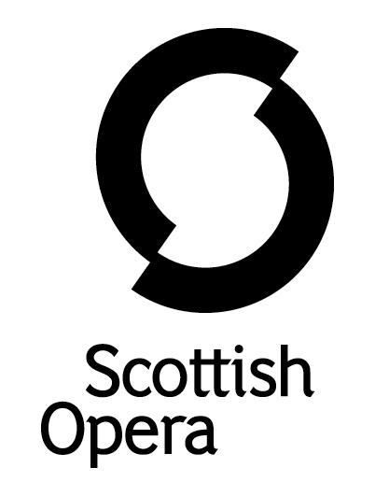

Press Release

17 September 2020

SCOTTISH OPERA WELCOMES FOUR SINGERS TO THE 20/21 EMERGING ARTISTS PROGRAMME

Scottish Opera welcomes a talented new group of singers to the 20/21 Emerging Artists programme: Scottish soprano Catriona Hewitson, French mezzo soprano Margo Arsane, Chinese tenor Shengzhi Ren and Scottish baritone Arthur Bruce.
Despite an uncertain year for the arts sector the company are thrilled to once again be able to offer a group of young artists a period of full time work at the beginning of their careers, to help them develop their skills across a broad range of performance and training opportunities. The Scottish Opera Emerging Artists programme was originally set up to nurture outstanding young singers and has continued to do so for 11 years. Previous Emerging Artists include soprano Jennifer France, tenor Elgan Llŷr Thomas, baritone Ben McAteer, repetiteur Jonathon Swinard, and composers Gareth Williams and Lliam Paterson.
The Emerging Artists will have opportunities to perform with Scottish Opera in both digital and live productions, as well as work in-house with visiting teachers and in masterclasses. All four singers will also perform in an online version of the company’s established Opera Highlights, with hopes to tour the production to theatres around Scotland in Winter/Spring, subject to government advice and guidelines.

The company welcomes back baritone Arthur Bruce as The Robertson Trust Scottish Opera Emerging Artist for a second year. Following a successful season with the company last year, Arthur also recently performed as Schaunard in the company’s five-star production of La bohème, staged at Scottish Opera’s Edington Street Production Studios in Glasgow.
Soprano Catriona Hewitson starts the programme in Janáček’s The Diary of One Who Disappeared, streamed live online on Sunday 20 September as part of the Lammermuir Festival.
Scottish Opera’s Head of Casting, Sarah-Jane Davies said: ‘We are extremely delighted to welcome four talented artists to the programme this year. Arthur Bruce returns, fresh from his success in our outdoor live performances of La bohème along with new artists Catriona Hewitson, Margo Arsane and Shengzhi Ren. It’s the first time we have representatives of the four main voice types – soprano, mezzo-soprano, tenor and baritone – which will make for some exciting opportunities as they embark on their programme with us. We look forward to working closely with them in realising all that Scottish Opera has on offer, including specialist coaching, diverse performance experience, professional guidance and being part of a national company, to name a few.’
Mezzo soprano Margo Arsane said: ‘I am very excited to be joining one of the UK's top opera companies, and even more so Scottish Opera, which is known for being so welcoming and warm. I am particularly looking forward to the variety of experiences I will gain as an Emerging Artist – which will give me the opportunity to work on the main stage with a team of exciting international guest artists, and therefore gain valuable exposure in the industry. As a young singer at the start of my career, having access to high-quality mentorship and music coaching from Scottish Opera’s in-house and visiting teams is invaluable. I deeply admire what Scottish Opera has been able to do since the Covid-19 crisis hit - they have shown such creativity in adapting to these troubled times, so it is humbling and exciting to get to be part of this team.’
Catriona Hewitson said: ‘It is completely overwhelming to have the opportunity to grow and work with a national company like Scottish Opera. I am also so excited to get to know Glasgow and see more of Scotland. I have spent the last decade in England so it is so lovely to be home again.’

Tenor Shengzhi Ren said: ‘As a singer from the East, ever since I began my studies it has been my dream to sing and perform in a national opera company. I am very honoured to have been chosen to join the Emerging Artists Programme at Scottish Opera, where I will have the opportunity to work with so many wonderful singers, conductors and directors. I am really looking forward to rehearsals and performances, and believe it will be a great journey.’
The Emerging Artists are supported by The Robertson Trust, Elizabeth Salvesen and Scottish Opera’s Emerging Artist Benefactors.

-ENDS-
www.scottishopera.org.uk

Notes to Editors

Soprano Catriona Hewitson studied at the Royal College of Music Opera Studio, the Royal Northern College of Music, ENO Opera Works and City of Edinburgh Music School. Catriona won the 2018 Kathleen Ferrier Loveday Song Prize and was a finalist in the Maureen Lehane Vocal Awards and Royal Over-Seas League Vocal Category. Catriona performed with the Grange Festival in its inaugural season as Cis Albert Herring and as Donna Rinaldo for Glyndebourne Touring Opera as well as covering principal roles for Glyndebourne Festival Opera, Garsington Opera and English Touring Opera. Other roles include Susanna Le nozze di Figaro, directed by Sir Thomas Allen, Tytania A Midsummer Night’s Dream and Edwige in Offenbach’s Robinson Crusoe (RCM). Highlights on the concert platform include touring with the Ulster Orchestra and performing at the Royal Albert Hall, Bridgewater Hall, Cadogan Hall, St Martin-in-the-Fields, Queen’s Hall, and at the Edinburgh International and Lammermuir Festivals.
Margo Arsane is a mezzo-soprano, who pursued her vocal training at the National High Conservatory of Music and Dance in Lyon and in Munich, before joining the opera course at the Guildhall School of Music and Drama and the National Opera Studio in London where she studied with Gary Coward and Dennis O’Neill. She has won several prizes including, first prize Mozarteum Sommerakademie Wettbewerb, Special Prize at the International Voice Competition in Marmande and ‘Young Hope’ Prize at the Concours International de Chant de Clermont-Ferrand. Performances include Cherubino Le nozze di Figaro Dartington Festival, cover Mélisande Pelléas et Mélisande Garsington Opera, Concepcion L’Heure Espagnole Festival Pentecote en Berry, Polissena Handel’s Radamisto GSMD. Margo has sung in public masterclasses for world-renowned singers Renée Fleming, Gerald Finley, Teresa Berganza, Stuart Skelton, Leontina Vaduva, Jean-Philippe Lafont and Janet Williams.
Chinese tenor Shengzhi Ren is a graduate of the 2019/20 National Opera Studio’s Young Artist Programme and the Royal Academy of Music, London where he studied with Richard Berkeley-Steele and Ingrid Surgenor. Before coming to the UK, Shengzhi trained at the Shanghai Conservatory of Music, where he graduated with Bachelor’s and Master’s degrees in bel canto with honours. Shengzhi’s operatic roles include Vaudémont, Iolanta, Don Josè, La tragedie de Carmen, Tamino, The Magic Flute, Nemorino, L’elisir d’amore and Borsa, Rigoletto. During 2018 Shengzhi sang at the London Bel Canto Festival Concert at the National Liberal Club, and in the Academy Voices Concert at Istituto Italiano di Cultura. In 2017, he performed as a soloist at the Korea-China Cultural Exchange Night. Shengzhi’s opera scene performances include Chevalier Belfiore, Il viaggio a Reims, Fenton, Falstaff, Ruggero, La rondine, Alfredo, La traviata, and Rodolfo, La bohème at the RAM; Prince, Cinderella for Opera North and Rodolfo, La Bohème in concert with Welsh National Opera.
Scottish baritone Arthur Bruce will return as The Robertson Trust Scottish Opera Emerging Artist for a second year. In his 2019/20 Season with the company, Arthur performed in a new production, Amadeus & The Bard: 18th Century Cosmic Brothers, about the links between Wolfgang Amadeus Mozart and Robert Burns. He also joined the Spring Opera Highlights tour, which was widely praised, and recently performed the role of Schaunard in Scottish Opera’s outdoor La bohème.
Arthur is a graduate of the Royal Conservatoire of Scotland's Alexander Gibson Opera School, the Royal Northern College of Music and English National Opera's Opera Works programme. He was also a member of Scottish Opera Young Company (formerly Connect). He has performed roles with Bampton Classical Opera, Berlin Opera Academy, Saffron Opera Group, Opera Eos, Edinburgh Grand Opera, London Young Sinfonia, Edinburgh Players Opera Group and Bowdon Festival Opera. He is also a Britten-Pears Young Artist.

Scottish Opera is Scotland’s national opera company and the largest performing arts organisation in Scotland. It was founded by Alexander Gibson in 1962 and was inaugurated with a production of Madama Butterfly at the King's Theatre in Glasgow.

Notable achievements include the world premiere of James MacMillan's Inés de Castro at the 1996 Edinburgh International Festival; complete Ring cycles at the 2003 Edinburgh International Festival, which won the 2004 South Bank Show Award for Best Opera Production; and the Achievement in Opera Award at the 2017 UK Theatre Awards for Sir David McVicar’s production of Debussy’s Pelléas and Mélisande. Recent commissions include Five:15 Operas Made in Scotland (2008-10); The Lady from the Sea, Clemency, the double bill of In the Locked Room and Ghost Patrol (winner of a South Bank Sky Arts Award) which premiered at the 2012 Edinburgh International Festival and 2016's The Devil Inside by Stuart MacRae and Louise Welsh. Earlier this year the Company made its US debut with BambinO at the Metropolitan Opera New York, and returns to the city’s Brooklyn Academy of Music with Greek in December.

Scottish Opera is committed to bringing the widest possible range of opera, performed to the highest possible standards, to the maximum audience throughout Scotland and the UK. Each year it performs in Glasgow, Edinburgh, Aberdeen and Inverness, as well as smaller theatres, village halls and community centres throughout the country.

Scottish Opera’s Education and Outreach Department was the first of its kind of any opera company in Europe. It operates an extensive programme which involves over 8,000 primary school children every year as well as many other activities including adult learning and Unwrapped taster sessions.

Scottish Opera is supported by the Scottish Government.

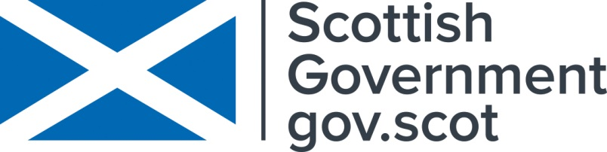

For additional press details please contact:
Julie McLaughlin, Press Officer, 07825981241, julie.mclaughlin@scottishopera.org.uk

