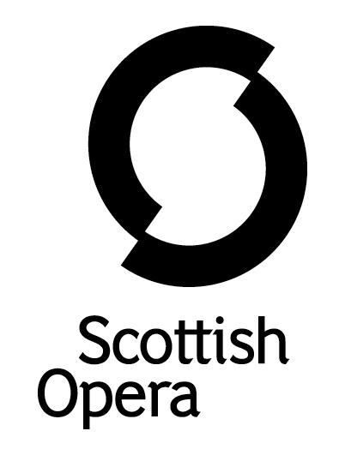

Press Release

2 September 2021

SCOTTISH OPERA leads new community project ‘SWEET SOUNDS IN WILD PLACES’ as part of the 250th ANNIVERSARY CELEBRATIONS OF SIR WALTER SCOTT

A series of free workshops led by Scottish Opera have been launched to help build creative skills and increase self-confidence and self-expression, in partnership with The Abbotsford Trust and Live Borders!

'Sweet Sounds in Wild Places' is open to anyone aged 18 and over identifying as female, and during the sessions artists from the Company will use music, creative writing, film and photograph to empower those who have been struggling during lockdown.

Forming part of the 250th anniversary celebrations of Sir Walter Scott, his novel The Bride of Lammermoor will be used as inspiration to explore issues such as loneliness, isolation and lack of empowerment, as well as the impact, for good and bad, that landscape and environment can have on our mental health and well-being.

Those interested in taking part have until Friday 17 September to reserve a place, with workshops in Hawick and Galashiels starting on Monday 27 September, and running until Monday 15 November. For more information on the workshops and how to sign up visit https://tinyurl.com/SweetPlaces
Jane Davidson, Scottish Opera’s Director of Outreach and Education said: ‘The past 18 months has been a challenging time for many people, and even although some things are returning to normal, some of us are left with feelings of loneliness, isolation and anxiety that can make it difficult to re-connect with our usual activities, social circles or with the places where we live and work.

‘If you’re interested in learning more about any of the art forms involved – even if you haven’t tried them before – and are keen to meet others who share similar interests, experiences and concerns in a supportive and friendly environment, please come and join us at the ‘Sweet Sounds in Wild Places’ sessions.’

Places are limited and will be allocated on a first come, first served basis. The sessions will take place on Mondays at Heart of Hawick (2-4pm), and Focus Community Centre, Galashiels (6-8pm). For bookings at either venue, please contact Art Services on 01750 726 400 or email artservice@liveborders1.org.uk.

The art work created during the workshops will be displayed in 2022 at a public exhibition at Abbotsford, the home of Sir Walter Scott, near Melrose. The final part of the project takes place at Abbotsford’s Visitor Centre on Saturday 4 December and Sunday 5 December. Transport will be available by bus, free of charge, to and from a central pick up point in Hawick and in Galashiels. Lunch will be provided.

This project is supported by The Cruden Foundation and Scottish Opera’s Education Angels.

-ENDS-
www.scottishopera.org.uk
You can follow Scottish Opera on Twitter, Facebook and Instagram @ScottishOpera

Notes to Editors

All productions are created and performed in line with Scottish Government guidelines.
The Company’s Opera on Screen productions are available to watch at: www.scottishopera.org.uk/what-s-on/opera-on-screen/.
The collection includes Donizetti’s L’elisir d’amore, Humperdinck’s Hansel and Gretel, Mozart’s Così fan tutte, Opera Highlights, Janáček’s The Diary of One Who Disappeared, Menotti’s The Telephone and Samuel Bordoli and Jenni Fagan’s The Narcissistic Fish.
Scottish Opera is Scotland’s national opera company and the largest performing arts organisation in Scotland.
The Company's performance repertoire ranges across five centuries, from the earliest operas to newly-commissioned world premieres, working in collaboration with the world's finest singers and creatives, alongside The Orchestra of Scottish Opera and choruses. Recent accolades include a South Bank Sky Arts Award, a Scottish Award for New Music, Sunday Herald Culture Awards and a Herald Angel, as well as a 2020 RPS Award.
The Company tours extensively across Scotland, from the largest-scale theatres to the smallest of rural venues, to ensure we are within reach of as many of our country's very dispersed population as possible. Our specially-adapted 40-foot long trailer brings ‘Pop-up Opera’ performances to thousands of people each year in a range of inspiring and unexpected community locations. This represents the most extensive touring programme of any opera company in Europe and is a much-valued contribution to Scotland’s cultural and artistic life, particularly in remote and island communities.
The Company’s Education and Outreach programme, which celebrates 50 years in 2021, includes an annual Primary Schools Tour, bringing upper primary-aged children the opportunity to perform their own specially-commissioned piece, alongside three professional singers. Around 120 schools and 9,000 pupils take part each year.
Scottish Opera aims to be inclusive and affordable through availability of free and cheap tickets, as well as performances offering audio description, and specially-devised shorter access performances.
Scottish Opera is core funded by The Scottish Government

For additional press details please contact:
Emily Henderson, Press Manager, 0141 242 0511,emily.henderson@scottishopera.org.uk
Julie McLaughlin, Press Officer, 0141 242 0552, julie.mclaughlin@scottishopera.org.uk

