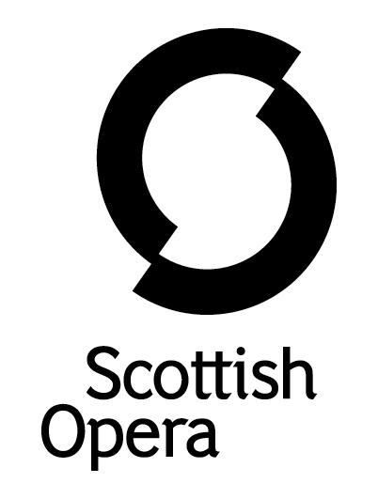

Press Release

Wednesday 6 October

SCOTTISH opera presents a festive musical for young children this december

Scottish Opera presents Mister MacNeep Has Lost His Sheep, a festive musical adventure specially created for children aged 3 to 7 this December, at the Company’s Edington Street Production Studios in Glasgow.

Running for a total of 28 performances from 3 to 20 December, this 45-minute, family friendly show immerses its young audience in live music, along with interactive puppetry that encourages the children to sing, dance and get involved in the production. Midweek performances are for school groups, while weekend shows will be available for the public to attend.

With music written by former Scottish Opera Composer in Residence, Gareth Williams and words by Ross Stenhouse (Tiny Chef 2019), the story invites children to help Farmer MacNeep and his sheepdog Flossie on their search party to find his favourite sheep, Laa-mie and Baa-mie, on a cold, snowy, winter evening. But unbeknown to Farmer MacNeep the clever pair build themselves a cosy cave in the snow to weather the winter months. However, worried for their safety, Flossie and Farmer MacNeep require the assistance of the audience along with their farmyard buddies if they are to find the lost duo in time for Christmas.

The shows are brought to life by director Allan Dunn, performed by soprano Marie Claire Breen and actor Chris Alexander, alongside cellist Andrew Drummond Huggan and percussionist Darren Gallacher.

Scottish Opera’s Director of Education, Jane Davidson, said: ‘At the end of another difficult year for live performance, we are so thrilled to be bringing this delightful Christmas production back (from 2014) for our youngest audiences. The little ones will be enchanted by this funny and gentle story along with some beautiful moments in the music which complement the story and highlight the importance of families and friends looking out for one other. The children can really get lost in the performance with plenty of opportunities to interact with the characters through jokes, songs and dances.’

Mister MacNeep Has Lost His Sheep is supported by Garfield Weston Foundation (Weston Culture Fund), The W. A. Cargill Fund and Scottish Opera’s Education Angels.

Tickets go on sale on Wednesday 6 October at www.scottishopera.org.uk/what-s-on/

You can follow Scottish Opera on Twitter, Facebook and Instagram @ScottishOpera

ENDS

Cast and Creatives

Soprano Marie Claire Breen
Actor Chris Alexander
Percussion Darren Gallacher
Cellist Andrew Drummond Huggan
Revival Director Allan Dunn
Original Director Lisa Gregan
Composer/ Music Director Gareth Williams
Designers Marian Colquhoun & Alice Hebdon

Public Performance Diary

Scottish Opera Production Studios, 40 Edington St, Glasgow G4 9RD

Saturday 4 December, 10.30am and 1.30pm
Sunday 5 December, 10.30am and 1.30pm
Saturday 11 December, 10.30am and 1.30pm
Sunday 12 December, 10.30am and 1.30pm
Saturday 18 December, 10.30am and 1.30pm
Sunday 19 December, 10.30am and 1.30pm

Schools Performance Diary

Friday 3 December, 10.30am and 1.30pm
Wednesday 8 December, 10.30am and 1.30pm
Thursday 9 December, 10.30am and 1.30pm
Friday 10 December, 10.30am and 1.30pm
Wednesday 15 December ,10.30am and 1.30pm
Thursday 16 December, 10.30am and 1.30pm
Friday 17 December, 10.30am and 1.30pm
Monday 20 December, 10.30am and 1.30pm

Notes to Editors

All productions are created and performed in line with Scottish Government guidelines.
The Company’s Opera on Screen productions are available to watch at: www.scottishopera.org.uk/what-s-on/opera-on-screen/.
The collection includes Donizetti’s L’elisir d’amore, Humperdinck’s Hansel and Gretel, Mozart’s Così fan tutte, Opera Highlights, Janáček’s The Diary of One Who Disappeared, Menotti’s The Telephone and Samuel Bordoli and Jenni Fagan’s The Narcissistic Fish.
Scottish Opera is Scotland’s national opera company and the largest performing arts organisation in Scotland.
The Company's performance repertoire ranges across five centuries, from the earliest operas to newly-commissioned world premieres, working in collaboration with the world's finest singers and creatives, alongside The Orchestra of Scottish Opera and choruses. Recent accolades include a South Bank Sky Arts Award, a Scottish Award for New Music, Sunday Herald Culture Awards and a Herald Angel, as well as a 2020 RPS Award. In 2021 the Company returned to live audiences with Sir David McVicar’s new production of Verdi’s Falstaff performed in Glasgow and at Edinburgh International Festival.
The Company tours extensively across Scotland, from the largest-scale theatres to the smallest of rural venues, to ensure we are within reach of as many of our country's very dispersed population as possible. Our specially-adapted 40-foot long trailer brings ‘Pop-up Opera’ performances to thousands of people each year in a range of inspiring and unexpected community locations. In the Summer of 2021 the Company performed over 200 shows of its Pop-up Opera Roadshow, to socially distanced audiences of over 8000. This represents the most extensive touring programme of any opera company in Europe and is a much-valued contribution to Scotland’s cultural and artistic life, particularly in remote and island communities.

The Company’s Education and Outreach programme, which celebrates 50 years in 2021, includes an annual Primary Schools Tour, bringing upper primary-aged children the opportunity to perform their own specially-commissioned piece, alongside three professional singers. Around 120 schools and 9,000 pupils take part each year.
Scottish Opera aims to be inclusive and affordable through availability of free and cheap tickets, as well as performances offering audio description, and specially-devised shorter access performances.

Scottish Opera is core funded by The Scottish Government

For additional press details please contact:
Emily Henderson, Press Manager, 0141 242 0511,emily.henderson@scottishopera.org.uk
Julie McLaughlin, Press Officer, 0141 242 0552, julie.mclaughlin@scottishopera.org.uk

