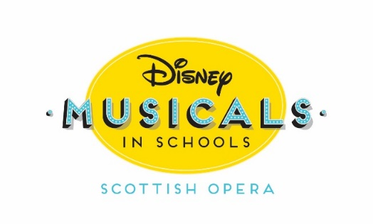
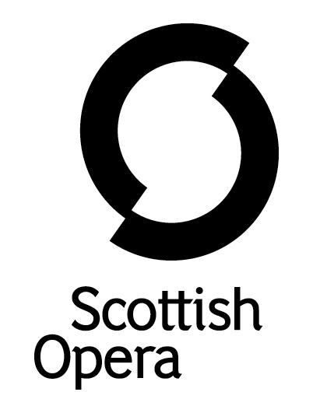

Press Release

25 October 2021

SCOTTISH OPERA AND DISNEY MUSICALS IN SCHOOLS JOIN FORCES ONCE AGAIN

Scottish Opera and Disney Musicals in Schools are collaborating to give five primary schools in Scotland the opportunity to learn and produce their own Disney KIDS musical including The Lion King KIDS and Aladdin KIDS. The pupils then have the opportunity to perform two special shows at Theatre Royal Glasgow and in their schools.

Disney Musicals in Schools features Disney KIDS musicals, which are shorter stage adaptions of classic Disney stories written expressly for primary school performers. The programme aims to build skills and confidence in both pupils and teachers, encourage participation and collaboration, and leave a sustainable arts legacy for years to come, especially in schools that are actively seeking greater engagement with the arts.

Following a selection process by Scottish Opera, the schools chosen to take part in the free Disney Musicals in Schools programme are Cleeves Primary School in Glasgow, St James Primary School in Renfrewshire, Edinbarnet Primary School in West Dunbartonshire, Hurlford Primary School in East Ayrshire and Wemyss Bay Primary School in Inverclyde. In October, the pupils from the five selected schools start working with two music and drama artists from Scottish Opera’s Outreach and Education Department, with step-by-step workshops covering every aspect of casting, rehearsing, staging and performing a 30-minute long version of one of Disney’s musicals.

Over a 17-week period, the Scottish Opera teaching artists guide pupils through music and movement, and work with staff to give them experience in singing, stage directing, choreography and stage management. The schools are also provided with a Disney Show Kit including scripts, director’s guide, music score, choreography DVD, and rehearsal and accompaniment CDs.
The programme with Disney and Scottish Opera first took place in Scotland in 2019 and involved primary schools in Irvine, Paisley, Stirling, Galashiels and Johnstone, however was cut short due to the Covid-19 pandemic. The schools involved have since been able to continue the project over the last few months and finishes up in November, later presenting their shows in Spring 2022.
Disney Musicals in Schools was first launched ten years ago as an outreach initiative designed to develop theatre programmes in New York Elementary Schools, and then in London in 2016.
Jane Davidson, Head of Outreach and Education at Scottish Opera said: ‘We are delighted to continue as Disney Musicals in Schools’ very first Scottish partner in the consolidated (due to the pandemic) delivery of years 2 & 3 of a three year in-depth, skill building programme for schools. This unique project is designed not only to introduce teachers to the key elements involved in preparing their pupils to stage one of Disney’s classical musicals but also, through interaction with parents and families, to help establish the role of the arts as a valuable tool in consolidating the school at the heart of the community it serves. Both organisations are firm advocates of the power of the arts to support integrated learning; to enhance attainment levels and to build a child’s capacity to achieve their potential and we hope that access to the extensive learning and teaching resources we have to offer, helping them to support their pupils even more effectively in the future.’

Nancy Shakerley, Education and Outreach Manager, Disney Theatrical Productions said: ‘We are thrilled to see Scottish Opera launch into year two of Disney Musicals in Schools with such enthusiasm and energy. After a challenging year for the Disney Musicals in Schools worldwide, the five schools selected to take part in Scotland are the first to launch into producing their shows. Now more than ever pupils and teachers alike can benefit from an opportunity to be creative, collaborative and to celebrate their skills and achievements. The team at Scottish Opera are incredibly talented and passionate about their work in schools, so, the children and their teachers are in safe and inspirational hands!’

Hazel Sim, Head Teacher at Cleeves Primary School, added: ‘The children, staff and families of Cleeves Primary School are delighted to be taking part in Disney Musicals for Schools this year. After almost two years of restrictions and lockdowns negatively impacting our expressive arts programme we are over the moon to be back, and what better way is there to do it? Our corridors are already echoing with the sound of Disney’s The Lion King and we can’t wait to watch our talents, confidence and teamwork develop over the next 17 weeks. Thank you so much for giving our school community this amazing opportunity.’

-ENDS-

www.scottishopera.org.uk

You can follow Scottish Opera on Twitter, Facebook and Instagram @ScottishOpera

Notes to Editors

Scottish Opera biography
The Company’s Opera on Screen productions are available to watch at: www.scottishopera.org.uk/what-s-on/opera-on-screen/.
The collection includes Donizetti’s L’elisir d’amore, Humperdinck’s Hansel and Gretel, Mozart’s Così fan tutte, Opera Highlights, Janáček’s The Diary of One Who Disappeared, Menotti’s The Telephone and Samuel Bordoli and Jenni Fagan’s The Narcissistic Fish.
Scottish Opera is Scotland’s national opera company and the largest performing arts organisation in Scotland.
The Company's performance repertoire ranges across five centuries, from the earliest operas to newly-commissioned world premieres, working in collaboration with the world's finest singers and creatives, alongside The Orchestra of Scottish Opera and choruses. Recent accolades include a South Bank Sky Arts Award, a Scottish Award for New Music, Sunday Herald Culture Awards and a Herald Angel, as well as a 2020 RPS Award. In 2021 the Company returned to live audiences with Sir David McVicar’s new production of Verdi’s Falstaff performed in Glasgow and at Edinburgh International Festival.
The Company tours extensively across Scotland, from the largest-scale theatres to the smallest of rural venues, to ensure we are within reach of as many of our country's very dispersed population as possible. Our specially-adapted 40-foot long trailer brings ‘Pop-up Opera’ performances to thousands of people each year in a range of inspiring and unexpected community locations. In the Summer of 2021 the Company performed over 200 shows of its Pop-up Opera Roadshow, to socially distanced audiences of over 8000. This represents the most extensive touring programme of any opera company in Europe and is a much-valued contribution to Scotland’s cultural and artistic life, particularly in remote and island communities.

The Company’s Education and Outreach programme, which celebrates 50 years in 2021, includes an annual Primary Schools Tour, bringing upper primary-aged children the opportunity to perform their own specially-commissioned piece, alongside three professional singers. Around 120 schools and 9,000 pupils take part each year.

Scottish Opera aims to be inclusive and affordable through availability of free and cheap tickets, as well as performances offering audio description, and specially-devised shorter access performances.

Scottish Opera is core funded by The Scottish Government

About Disney Theatrical Productions

DISNEY THEATRICAL PRODUCTIONS, a division of The Walt Disney Studios, was formed in 1994 and operates under the direction of Thomas Schumacher. Worldwide, its 10 Broadway titles have been seen by nearly 200 million theatergoers and have been nominated for 60 Tony® Awards, winning Broadway’s highest honor 20 times. With 20 productions currently produced or licensed, a Disney musical is being performed professionally somewhere on the planet virtually every hour of the day.

The company’s inaugural production, Beauty and the Beast, opened in 1994. It played a remarkable 13 year run on Broadway and has been produced in 37 countries worldwide.

In November 1997, Disney opened The Lion King, which received six 1998 Tony Awards including Best Musical. After 22 landmark years on Broadway, it has welcomed more than 100 million visitors worldwide to date, and can currently be seen in nine productions worldwide. Having played 20 countries on every continent except Antarctica, The Lion King’s worldwide gross exceeds that of any film, Broadway show or other entertainment title in box office history.

Elton John and Tim Rice’s Aida opened on Broadway next, winning four 2000 Tony Awards. It was followed by Mary Poppins, a co-production with Cameron Mackintosh, which opened in London in 2004 and went on to enjoy a six year Tony-winning Broadway run.

Tarzan®, which opened on Broadway in 2006, went on to become an international hit with an award-winning production enjoying a 10-year run in Germany. In January 2008, The Little Mermaid opened on Broadway and was the #1-selling new musical of that year.

Disney Theatrical Productions opened two critically acclaimed productions on Broadway in 2012, receiving seven Tony Awards between them: Peter and the Starcatcher and Newsies, each of which enjoyed a two-year run with the latter launching a two-year North American tour and a record-breaking Fathom Events’ in-cinema release.

Aladdin, Disney Theatrical’s 2014 hit, continues selling out on Broadway and has launched five additional productions around the globe and has been seen by more than 10 million guests. Its newest hit, the 2018 Tony-nominated Best Musical Frozen, continues setting records in its Broadway run with future productions set to open in Australia, Japan, London, Germany and on tour across North America.

Other successful stage ventures have included the Olivier-nominated London hit Shakespeare in Love, stage productions of Disney’s High School Musical, Der Glöckner Von Notre Dame in Berlin, and King David in concert. DTP has collaborated with the nation’s preeminent theatres to develop new stage musicals including The Jungle Book, The Hunchback of Notre Dame, Freaky Friday and in August Hercules.

As a part of the recent acquisition of 21st Century Fox, DTP also heads the Buena Vista Theatrical banner which licenses Fox titles for stage adaptations including Anastasia; Moulin Rouge! The Musical; Mrs. Doubtfire and The Devil Wears Prada.

For additional press details please contact:
Emily Henderson, Press Manager, 0141 242 0511, emily.henderson@scottishopera.org.uk
Julie McLaughlin, Press Officer, 0141 242 0552, julie.mclaughlin@scottishopera.org.uk

