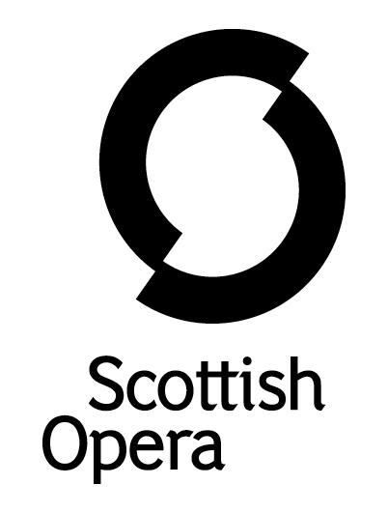

Press Release

9 March 2022

CALL OUT FOR COMMUNITY CHORUS MEMBERS FOR SCOTTISH OPERA’S NEW OUTDOOR PRODUCTION OF LEONARD BERNSTEIN’S CANDIDE

In Glasgow this summer, Scottish Opera is staging a one of a kind, outdoor promenade production of Leonard Bernstein’s satirical opera, Candide, and is appealing to members of the public from all walks of life to join the show’s community chorus.

Celebrating the diversity and creativity of Scotland’s communities, there will be six performances of this vibrant and contemporary take on Bernstein’s work in August, with the community chorus members taking to the stage alongside a 150-strong cast which includes professional singers and a live orchestra. The performances will be held under a purpose-built marquee tent.

The casting call is open to individual participants aged over 16, as well as family groups with children aged over 10. No experience is required – Scottish Opera is looking for anyone who enjoys singing, dance or acting, or who want to join a fun, supportive, community project to make new friends and get to know Glasgow better. Free childcare facilities are available and the rehearsal and performance spaces are fully accessible, welcoming participants of all abilities. Those taking part will be supported at all stages of the process, including by being provided with listening materials to make learning the music an enjoyable experience.

Candide, written by Bernstein before he composed his hit musical West Side Story, follows larger-than-life characters in chaotic adventures across Europe and South America. Is the chaos they encounter really the best of all possible worlds, or must they find simple happiness within themselves? Full of imagination and comedy, the production is updated for today’s global communities, mirroring the complex, heart-breaking, but ultimately life affirming stories that have moved and inspired people throughout history. As Candide is tossed between misfortunes on his travels, the story is particularly relevant to issues of displacement and refugees today.

A Community Chorus last featured in the 2018 Scottish Opera promenade production of Ruggero Leoncavallo’s Pagliacci, staged in a huge tented structure in Paisley. Recruited from Renfrewshire and the surrounding areas, they performed side-by-side with a cast of international soloists, a professional chorus and The Orchestra of Scottish Opera.

Full details about Candide will be released in May.

For more information email communitychorus@scottishopera.org.uk by 7 April.

-ENDS-

www.scottishopera.org.uk
You can follow Scottish Opera on Twitter, Facebook and Instagram @ScottishOpera

Notes to Editors
All productions are created and performed in line with Scottish Government guidelines.
The Company’s Opera on Screen productions are available to watch at: www.scottishopera.org.uk/what-s-on/opera-on-screen/.
The collection includes Donizetti’s L’elisir d’amore, Humperdinck’s Hansel and Gretel, Mozart’s Così fan tutte, Opera Highlights, Janáček’s The Diary of One Who Disappeared, Menotti’s The Telephone and Samuel Bordoli and Jenni Fagan’s The Narcissistic Fish.
Scottish Opera is Scotland’s national opera company and the largest performing arts organisation in Scotland.
The Company's performance repertoire ranges across five centuries, from the earliest operas to newly-commissioned world premieres, working in collaboration with the world's finest singers and creatives, alongside The Orchestra of Scottish Opera and choruses. Recent accolades include a South Bank Sky Arts Award, a Scottish Award for New Music, Sunday Herald Culture Awards and a Herald Angel, as well as a 2020 RPS Award. In 2021 the Company returned to live audiences with Sir David McVicar’s new production of Verdi’s Falstaff performed in Glasgow and at Edinburgh International Festival.
The Company tours extensively across Scotland, from the largest-scale theatres to the smallest of rural venues, to ensure we are within reach of as many of our country's very dispersed population as possible. Our specially-adapted 40-foot long trailer brings ‘Pop-up Opera’ performances to thousands of people each year in a range of inspiring and unexpected community locations. In the summer of 2021 the Company performed nearly 200 shows of its Pop-up Opera Roadshow, to socially distanced audiences of 11,014 people. This is one of the most extensive touring programmes of any European opera company and a much-valued contribution to Scotland’s cultural and artistic life, particularly in remote and island communities.
The Company’s Education and Outreach programme, which celebrates 50 years in 2021, includes an annual Primary Schools Tour, bringing upper primary-aged children the opportunity to perform their own specially-commissioned piece, alongside three professional singers. Around 120 schools and 9,000 pupils take part each year.
Scottish Opera aims to be inclusive and affordable through availability of free and cheap tickets, as well as performances offering audio description, and specially-devised shorter access performances.
For additional press details please contact:
Emily Henderson, Press Manager, 0141 242 0511,emily.henderson@scottishopera.org.uk
Julie McLaughlin, Press Officer, 0141 242 0552, julie.mclaughlin@scottishopera.org.uk

