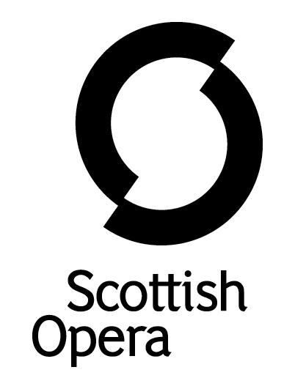

Press Release

13 May 2022

SCOTTISH OPERA TO PERFORM OPENING GALA FOR THE PERTH FESTIVAL OF THE ARTS 50TH ANNIVERSARY
On Thursday 19 May, at Perth Concert Hall, Scottish Opera is presenting a wonderful programme of some of opera’s most moving and delightful music to open Perth Festival of the Arts 50th Anniversary Festival.

The Brewin Dolphin Festival Gala Opening Concert features sopranos Eleanor Dennis and Catriona Hewitson, mezzo-sopranos Catriona Morison and Lea Shaw, and baritone Jonathan McGovern. Eleanor last performed in the Company’s 2016 production of The Marriage of Figaro, in the role of Countess Almaviva, whilst Catriona Hewitson, Lea and Jonathan appeared in the recent five-star production of A Midsummer Night’s Dream. Scottish mezzo-soprano and the winner of the BBC Cardiff Singer of the World Catriona Morison is making her debut with Scottish Opera. They will be conducted by the Company’s Music Director, Stuart Stratford, and accompanied by The Orchestra of Scottish Opera.
Featuring excerpts from Bizet’s best known opera Carmen, Mozart’s much-loved Don Giovanni and The Magic Flute, Strauss’ Der Rosenkavalier, Puccini’s one-act comic opera Gianni Schicci and second opera, Edgar, Werther (Massenet’s setting of Goethe’s tragic novel), and Humperdinck’s fairy tale opera Hansel and Gretel, each half of the performance opens with joyous showcases for The Orchestra of Scottish Opera. These are Shostakovich’s "Festive Overture ", a vivacious piece written in 1954 for the 37th anniversary of the October Revolution, and Wagner’s single comedy "Die Meistersinger", a simple story of art, love and tradition.

Scottish Opera Music Director, Stuart Stratford said: ‘It’s a great honour for Scottish Opera to perform at the Gala Opening Concert of the Perth Festival of the Arts, in its 50th Anniversary year. The five wonderful singers include Jonathan McGovern, who is about to sing the title role in our revival of Don Giovanni. He also, along with Catriona Hewitson and Lea Shaw, dazzled critics and audiences in A Midsummer Night’s Dream. There is so much to look forward to, ranging from instantly recognisable music from The Magic Flute to the sparkling comedy of Der Rosenkavalier. It promises to be a really special evening.’
David Brand, Chairman of Perth Festival of the Arts said: ’All of us at Perth Festival of the Arts are delighted that Scottish Opera is performing in The Brewin Dolphin Festival Gala Opening Concert on the historic occasion of our 50th Festival. Since 1972, the Festival has featured marvelously talented artists from all over the world and it is entirely appropriate that the splendid orchestra and singers of Scottish Opera are opening our 50th Anniversary. At our very first Festival, Scottish Opera performed both A Midsummer’s Night Dream and Così fan tutte, and we could not envisage a better way to mark the 50-year milestone and ensure a fantastic start to this year’s Festival.’
Tickets are available now from www.perthfestival.co.uk/event-The-Brewin-Dolphin-Gala-Opening-Concert-with-Scottish-Opera-id1557

The concert is part of the Festival, a gem in Scotland’s cultural calendar, with performances in Perth Theatre, Perth Concert Hall and other venues from 18-29 May and features the best in classical music, theatre, rock, folk, jazz, literature and visual art.
You can follow Scottish Opera on Facebook, Twitter and Instagram @ScottishOpera

-ENDS-

Performance dates and venues
Thursday19 May, 7.30pm, Perth Concert Hall, Mill Street, Perth, PH1 5HZ
Notes to Editors

Scottish Opera is Scotland’s national opera company and the largest performing arts organisation in Scotland. The 2022/23 season marks its 60th Anniversary.
The Company’s performance repertoire ranges across five centuries, from the earliest operas to newly-commissioned world premieres. Scottish Opera collaborates with the world’s finest singers and creatives, together with The Orchestra of Scottish Opera and choruses for each opera. Recent accolades include a South Bank Sky Arts Award, a Scottish Award for New Music, Sunday Herald Culture Awards, a Herald Angel, and a 2020 RPS Award. In 2021 the Company returned to live audiences with Sir David McVicar’s new production of Verdi’s Falstaff performed in Glasgow and at the Edinburgh International Festival.

The Company tours extensively across Scotland to ensure performances are within reach of as many of the country’s very dispersed population as possible. Specially-adapted 40-foot long trailers bring Pop-up Opera performances to thousands of people each year. In 2021 the Company performed nearly 200 performances of its Pop-up Opera Roadshow to socially distanced audiences of 11,014 people. This is one of the most extensive touring programmes of any European opera company and a much-valued contribution to Scotland’s cultural and artistic life, particularly in remote and island communities.

The Company’s Education & Outreach programme, which celebrated 50 years in 2021, includes an annual Primary Schools Tour, bringing children the opportunity to perform their own specially-commissioned piece alongside professional singers. Around 120 schools and 9,000 pupils take part each year. Scottish Opera aims to be inclusive and affordable through availability of free and cheap tickets, as well as performances offering audio description and specially-devised shorter access performances.

The Company’s Opera on Screen productions are available to watch at: www.scottishopera.org.uk/what-s-on/opera-on-screen. The collection includes Donizetti’s L’elisir d’amore, Humperdinck’s Hansel and Gretel, Mozart’s Così fan tutte, Opera Highlights, Menotti’s The Telephone, and Samuel Bordoli and Jenni Fagan’s The Narcissistic Fish. The Company’s 2021 production of The Gondoliers, filmed live at Festival Theatre Edinburgh, is available on BBC iPlayer.
Scottish Opera is core funded by The Scottish Government.

For additional press details please contact:
Emily Henderson, Press Manager, 0141 242 0511,emily.henderson@scottishopera.org.uk
Julie McLaughlin, Press Officer, 0141 242 0552, julie.mclaughlin@scottishopera.org.uk

