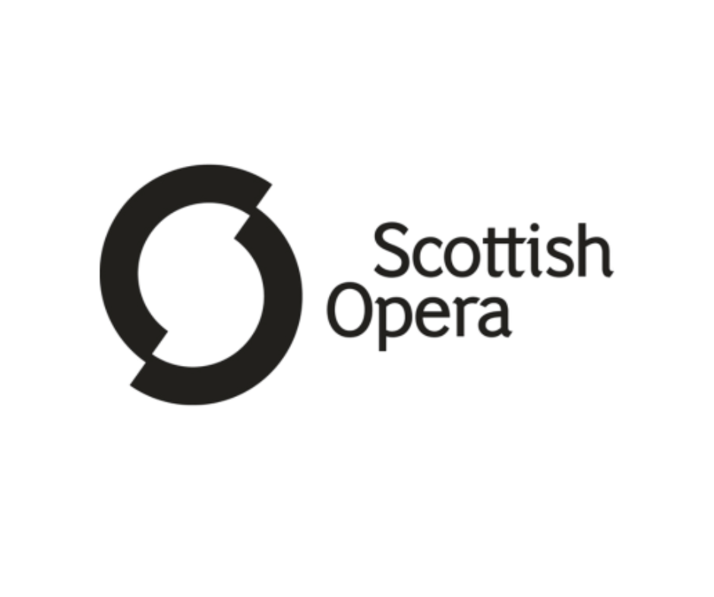

Candidate Pack: Corporate Partnerships Manager
Location: Hybrid, with 3 days in Glasgow Head Office (G2 4PT)
Salary: £35,000 - £40,000 per annum
Hours: Full time, 35-hours per week
Closing date: Midnight Tuesday 19th May 2026

Welcome from Isla Campbell Lupton, Director of Development at Scottish Opera
Thank you for your interest in joining Scottish Opera as our Corporate Partnerships Manager.

At Scottish Opera, our mission is to share the power and joy of opera with as many people as possible - from grand stage productions to community projects and education programmes that inspire the next generation. None of this would be possible without the generosity and enthusiasm of our supporters.

The Corporate Partnerships Manager role is new to Scottish Opera and will be an important addition to our Development team. We see real potential to grow our corporate partnerships. We already have several engaged and valued partners, and strong internal support to build on this work We also understand that developing this income stream takes time, and we are committed to a thoughtful, long-term approach to making it a success.

We have been working with an external partner to shape our approach to corporate partnerships and identify a strong pool of prospective partners to engage. This new role is a direct result of that work and will be central to delivering our corporate partnerships strategy.

I joined Scottish Opera 11 months ago and am loving being part of the team. It’s a varied and rewarding place to work, where fundraising activity is supported by the wider organisation and there is ample space to combine creativity with strategy, and relationship-building with storytelling. No two days are ever quite the same.

You’ll be joining a warm and collaborative organisation where everyone, on stage and off, works together to make world-class opera accessible to all. We don’t expect you to have a background in opera, but if you’re passionate about the arts this is an exciting and fulfilling place to work.

If you have experience in fundraising, love connecting with people, and want to make a tangible difference, we’d be delighted to hear from you.

Thanks for expressing interest,

Isla

Background on Scottish Opera
Scottish Opera’s mission is to entertain, inspire, surprise, educate, challenge, and delight audiences by delivering high quality, powerful, innovative opera throughout Scotland and internationally.
Scottish Opera is Scotland’s national opera company and the largest performing arts organisation in Scotland. The Company was founded in 1962 by Sir Alexander Gibson “to lay the treasures of opera at the feet of the people of Scotland”. The 2025/26 season marks its 63rd anniversary.
The Company’s productions have won worldwide critical acclaim. Performances range from the earliest operas to world premieres. All mainstage performances, regardless of language, are supertitled. Access (Dementia Friendly) and audio described performances further widen accessibility to opera. Scottish Opera provides free tickets to asylum seekers, refugees, and school groups and discounted tickets to those under the age of 26. Small-scale tours travel to every corner of the country. Education and Outreach programmes (run by the longest-standing department of its kind in Europe) make opera accessible to all ages, social backgrounds, and abilities, developing personal creativity, interest in opera, and wellbeing.
Scottish Opera is one of five National Performing Companies part funded by the Scottish Government. Fundraising plays an important role in securing income and support from individuals, trusts, and the private sector, alongside income from ticket sales, production hire, and manufacturing.

Scottish Opera’s mission and values
Scottish Opera’s Company mission
By speaking powerfully through all of their work, to entertain, inspire, surprise, educate, challenge and delight audiences old and new in delivering high quality opera throughout Scotland, the rest of the UK, and internationally.

Their values
Every day they aim to:
- Achieve excellence in everything: rigorous, discerning, astute, demanding
- Build strong partnerships: imaginative, collaborative, confident, smart, transparent, inclusive
- Reach beyond the comfort zone: courageous, curious, adventurous, leadership
- Work as a team: ambitious, energetic, coherent, respectful, trust, integrity

Context
- A National Performing Company funded directly by the Scottish Government and the only full-time, professional opera company in Scotland
- Scottish Opera attracts significant support from individuals, trusts, and the private sector alongside earned income from ticket sales, production hire, transport, and manufacturing
- Their artistic frame places existing audience favourites next to surprising, less familiar works and new commissions
- The Company regularly gives full-length, fully-staged opera performances and concerts in Glasgow, Edinburgh, Aberdeen and Inverness. It tours to all four corners of the country – from Lerwick and the Western Isles, to Stranraer and Kelso, and everywhere in between
- Scottish Opera contributes significantly to Scotland’s cultural ecology, retaining artists, creatives, artisans, and other performance-related professionals in Scotland through employment and training opportunities
- The Company’s extensive, integrated Outreach and Education programme is for people of all ages, social backgrounds and abilities, contributing to the development of individuals’ personal creativity, interest in opera and health and wellbeing
- Continually dedicated to the support and development of young artists, creatives and artisans

Background on the Corporate Partnerships Manager role

Why is this role vacant?

We have worked with an external partner to develop a clear strategy and identify opportunities to grow our corporate partnerships and will continue to build on this work together. This role is new to Scottish Opera and is a key part of delivering that strategy.

Currently, corporate partnership income is managed by the Director of Development; this role will provide dedicated capacity to proactively develop the pipeline, securing new partnerships and deliver excellent account management to our existing partners.

The team
Director of Development
- Trust Fundraising Manager
- Events Manager
- Data Manager
- Corporate Partnerships Manager

The Director also line manages the Head of Individual Giving (mat cover) who has responsibility for:
- Legacy and Planned Giving Manager
- Donor Development Manager
- Individual Giving Manager
- Fundraising Support Officer

The team are in a positive place with investment in fundraising over the past year, including increased remit and responsibility for the Legacy and Planned Giving Manager, and bringing the Donor Development Manager role into the organisation to support with developing new supporter relationships. The Corporate Partnerships Manager role will be an important addition to the team, brining dedicated focus to developing and growing our corporate partnership.

Key relationships

Internally:
- Director of Development
- Fundraising Department
- General Director
- Wider Scottish Opera team

Externally:
- Corporate Partners
- Board Members
- Artistic staff as required

Income expectations

Scottish Opera currently has a handful of key partners who support through cash donations, sponsorship and gift in kind support. Income expectations sit circa £80,000 for this financial year (Year One of the new strategy), with almost 60% of that income already committed from existing partners. The team is aiming to develop the income stream with income growth to circa £180,000 planned for Year Two.

Areas of potential

New opportunities to explore
Following the strategy development already undertaken, there is a corporate pipeline in place, giving the new post holder a strong foundation from which to begin.
There is a significant potential within the strategy, alongside a pragmatic and focused approach. Scottish Opera recognises the need to prioritise, with support in place to focus on the most immediate opportunities, while also taking a patient, long-term approach to developing corporate partnerships.

Internal buy in for Fundraising
There is a genuine organisation-wide approach to fundraising, championed from the top by the Chair and General Director, with a shared understanding that it is everyone’s responsibility.
The General Director and the Music Director are regularly involved in developing opportunities, making asks and generally supporting fundraising activity. There is a broad understanding across the wider organisation that fundraising success is integral to the wider success of Scottish Opera as a whole. Of course, there are still ways the staff base can further understand and support fundraising activity at an even deeper level, but the culture is very much in place to undertake that work with positive results.

Areas of challenge

Scale of potential
There is great variety at Scottish Opera, and an exciting, jam-packed calendar. There are many areas of potential to engage potential partners with Scottish Opera. The main challenge is to juggle business as usual alongside launching and managing new products and offers. Balancing and juggling priorities is a crucial skill for all successful fundraisers, and this role is no different.

Otherwise, there are no expected challenges on the horizon. The organisation is in a positive period, the team is in a stable place and lots of exciting opportunities to tap into.

Job Description: Corporate Partnerships Manager
Scottish Opera is seeking an ambitious and commercially minded Corporate Partnerships Manager to build and grow a dynamic portfolio of business partnerships that support their artistic ambition and national impact.
This is a new role with a clear focus: generating income, developing meaningful partnerships, and positioning Scottish Opera as a compelling partner for businesses across Scotland and beyond.
You will lead on identifying, securing, and nurturing corporate support, working at pace to convert opportunities into long-term relationships that deliver value for both partners and Scottish Opera.

Identify, research, and prioritise prospective corporate partners aligned with Scottish Opera’s ambition and brand.

Proactively generate and pursue new leads through networking, events, and sector insight.

Build and maintain a strong, active pipeline of opportunities with clear progression toward income.

Develop compelling, tailored partnership propositions that meet both business objectives and Scottish Opera priorities. Work closely with colleagues across fundraising, marketing, and artistic teams to shape partnership opportunities.

Lead on pitches and presentations, communicating with clarity, confidence, and commercial awareness.

Negotiate partnership agreements, securing strong financial and in-kind support.

Build visibility and relationships across the corporate and cultural sectors, proactively positioning Scottish Opera as a partner of choice.

Contribute towards a financial target and KPIs as agreed with the Director of Development.

Represent Scottish Opera at performances, events, and external networking opportunities.

Maintain accurate records of activity, pipeline, and income forecasting.

Work collaboratively across the fundraising team to deliver a seamless, high-quality experience for corporate partners and prospects.

To undertake any other duties which may reasonably be required.

Person Specification: Corporate Fundraising Manager

Experience and knowledge
- Proven charity experience in corporate fundraising, business development, or partnerships (or a comparable commercial role).
- Demonstrable track record of securing and growing significant income from corporate partnerships with demonstrable results against targets.
- Demonstrable written skills in creating compelling and engaging pitches, proposals, stewardships materials and daily communications, with the ability to tailor communications to a range of audiences.
- Understanding of what businesses want from partnerships and how to create mutual value.
- Strong interpersonal, influencing and relationship-management skills that demonstrate confidence and capability in building effective relationships across all levels including internal and senior stakeholders, potential high-value partners, existing supporter’s donors and others.
- An interest in the arts and an understanding of an arts environment would be an advantage.

Skills
- Strong written skills, creating clear and engaging pitches, proposals, stewardship materials and day-to-day communications, while tailoring messaging for different audiences and writing and speaking with clarity, warmth, and impact.
- Ability to identify opportunities, develop strategy, and convert prospects into partners.
- Able to effectively prioritise own workload, with the ability to manage multiple relationships and priorities simultaneously.
- Strong commercial awareness and the ability to “speak the language” of business.
- Presents professionally and confidently in both virtual and face-to-face settings, including leading meetings, attending events, networking, liaising with partners and key stakeholders, and representing Scottish Opera.
- Proactive and enthusiastic team player.
- Strong attention to detail, with accurate pipeline and relationship management, supported by confident use of CRM systems and Microsoft Office.

Benefits & life at Scottish Opera

Salary
Salary band is circa £36,000 - £40,000 per annum, full time 35 hours per week. Candidates will be appointed along the scale based on level of experience and performance at interview.

Location and travel

This post requires hybrid working from Scottish Opera’s offices in central Glasgow. The standard hybrid arrangement is three days working from the office per week.

This post also requires evening and weekend working as necessary.

The ability to meet partners at other locations is also required.

Annual Leave

35 days annual leave per year inclusive of Bank Holidays.

Hours and Flexible Working
Typical hours are 9.30am - 5.30pm with an hour’s lunch break.

Flexible working requests are welcomed.

Pension
You will be automatically enrolled into a qualifying workplace pension scheme (QWPS). You will contribute 4% of your salary, the Company contributes 8%.

Other
- Free tickets to Scottish Opera dress rehearsals and discounted performance tickets
- Enhanced sick pay and parental leave policies
- Cycle to Work scheme
- Perkbox
- Employee Assistance Programme
- Health Cash Plan

Scottish Opera hold Silver accreditation for National Centre of Diversity.

If you have questions about the benefit package, or if there are policies you would value seeing before continuing in the selection process, please do reach out via recruitment@thinkcs.org and we will be happy to find out the information you need.

Equality, Diversity and Inclusion
At Scottish Opera, their mission is to speak powerfully through all their work in order to entertain, inspire, surprise, challenge and delight audiences throughout Scotland, the rest of the UK and internationally. They know that having a diverse workforce is essential if they are going to deliver our mission.
They are committed to promoting equality and ensuring that no one is denied opportunities or discriminated against through prejudice or exclusion due to age, disability, gender reassignment, marriage and civil partnership, pregnancy and maternity, race, religion or belief, sex and sexual orientation. They particularly encourage applications from people that are under-represented in the Performing Arts and at Scottish Opera including those from black, Asian and minority ethnic backgrounds and disabled people. They have supportive working practices and work towards providing wherever possible a working environment that is inclusive and accessible for those with caring responsibilities.
This diversity of thought paired with a culture of inclusion is vital for them to continue to create work that is for everyone. This makes Scottish Opera a great place to work, where people are valued for who they are.
Both Scottish Opera and THINK Recruitment are committed to treating all applicants fairly and equally.
If there is anything THINK Recruitment can do to make any reasonable adjustments to ensure you can engage fully in the selection process, please contact Jo McGuinness at recruitment@thinkcs.org for a confidential discussion.

How to apply
To express interest in this role, please email recruitment@thinkcs.org with a copy of your CV.
Our recruitment manager will have a conversation with all credible applicants prior to shortlisting. Please ensure you get in touch with enough time to have an initial call and receive the screening questions ahead of the role closing.
Rather than requesting candidates submit a supporting statement or cover letter, we will provide interested candidates with screening questions to answer ahead of the role closing.

- Screening calls with THINK Recruitment: Friday 1st May – Tuesday 19th May
- Closing date: Midnight Tuesday 19th May 2026
- Invites out to interviewees: By midday Friday 22nd May 2026
- Stage 1 interviews: Wednesday 27th or Thursday 28th May 2026
- Stage 2 interviews: Tuesday 2nd or Wednesday 3rd June 2026
- Decision by: EOD Friday 5th June 2026

Both Stage 1 and Stage 2 interviews will be held in person at Scottish Opera offices in Glasgow. At point of invite to interview candidates will be provided with further information, including details on any tasks and the panel question themes to support candidate preparation.

If there are any reasonable adjustments THINK Recruitment can make to ensure ease of participation in the selection process, please do get in touch. All discussions are confidential.
Thank you for your interest, please do get in touch if you have any questions.
Jo McGuinness
Senior Recruitment Manager / recruitment@thinkcs.org

