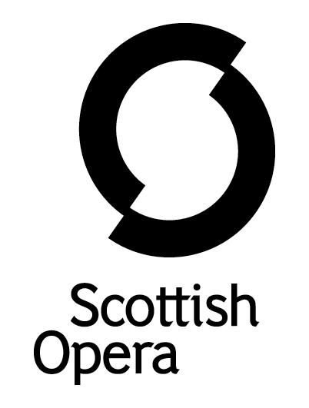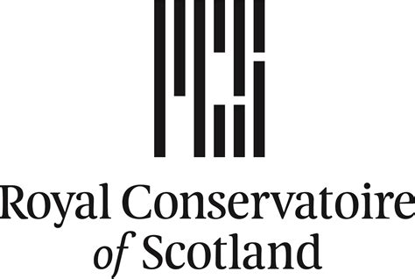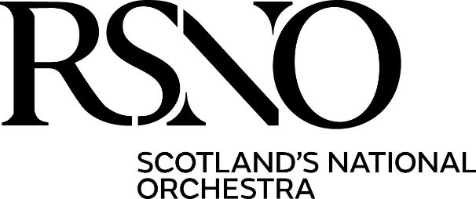

Press Release

28 January 2026

CENTENTARY CELEBRATIONS PLANNED TO MARK THE CULTURAL CONTRIBUTION OF SIR ALEXANDER GIBSON BY SCOTTISH OPERA, ROYAL SCOTTISH NATIONAL ORCHESTRA AND THE ROYAL CONSERVATOIRE OF SCOTLAND

February 11, 2026, marks the 100th anniversary of the birth of Sir Alexander Gibson, and to honour his life, legacy and continued impact through the companies he shaped and led during his lifetime, a special event is taking place at the Scottish Parliament, organised by Scottish Opera, Royal Scottish National Orchestra (RSNO) and the Royal Conservatoire of Scotland (RCS).

Dubbed ‘the maestro frae Motherwell’, Sir Alexander Gibson became the first Scot and longest-serving Principal Conductor and Music Director of the then Scottish National Orchestra. A few years into this role, Sir Alexander founded Scottish Opera, Scotland’s national opera company and largest performing arts organisation. A former student of RCS (then the Royal Scottish Academy of Music and Drama), the Alexander Gibson Opera School in Glasgow was established in his memory, along with a fellowship for choral conductors.

The three organisations are holding a centenary celebration at the Scottish Parliament in Edinburgh on February 25, 2026, to showcase his achievements and highlight the work of the companies in continuing to bring world-class opera and music to a diverse range of audiences in communities the length and breadth of Scotland. It is hosted by Clare Adamson, MSP for Motherwell and Wishaw, and Convener of the Constitution, Europe, External Affairs and Culture Committee, and Michelle Thomson MSP, Convener of the Cross-Party Group on Music.

Alex Reedijk, Scottish Opera General Director said: ‘We are looking forward to celebrating Sir Alexander’s life with his family, special guests, and our friends from the RSNO and RCS. He founded Scottish Opera ‘to lay the treasures of opera at the feet of the people of Scotland’ and was a tireless champion of Scottish music and musicians. The lasting impact of Sir Alex’s vision and leadership on Scottish culture cannot be overstated. The world premiere of our production of Dai Fujikura’sThe Great Wave on February 12, 2026, at Theatre Royal Glasgow will be dedicated to Sir Alexander to mark his birthday.’

Alistair Mackie, RSNO Chief Executive said: ‘Growing up as a young musician in Scotland,
I was always aware of what a huge musical presence Sir Alexander Gibson was, especially in attracting world-class artists to Scotland. I was lucky enough to see the likes of Jessye Norman, Yo-Yo Ma and Vladimir Ashkenazy perform in Glasgow thanks to Sir Alexander during his impressive 25-year tenure as Principal Conductor of the Scottish National Orchestra. Our cultural landscape would not be what it is today without him, and it feels only right that we are celebrating his 100th birthday with our good friends at Scottish Opera and RCS. On February 20 and 21, 2026, the RSNO will mark the centenary with a programme of Strauss and Bruckner in memory of Sir Alexander and his late wife Lady Veronica.’

Professor Jeffrey Sharkey, Principal of the Royal Conservatoire of Scotland said: ‘As we mark the centenary of the birth of Sir Alexander Gibson, we celebrate not only one of the most influential figures in music in Scotland, but a musician whose musical journey began here at the Royal Conservatoire of Scotland.

‘Sir Alexander’s legacy lives on in many ways including through the Opera School named after him at RCS, where generations of singers, conductors and creative artists have developed their craft, as well as through our strong partnerships with Scottish Opera and the Royal Scottish National Orchestra, both of which give students exceptional opportunities to learn and work alongside professionals in the national performing companies.

‘This centenary year and the commemorations to recognise it, create special moments for us to honour and celebrate Sir Alexander Gibson and the legacy of his wonderful contribution to music in Scotland.’

The Gibson family said: ‘We are proud of the amazing legacy our father has left behind; that his creativity and vision mean not only that the organisations he was involved with, led and founded, continue to flourish, but also that they are now creating livelihoods for hundreds of people and inspiring generations of performers and music lovers in Scotland and beyond.’

Born in Motherwell in North Lanarkshire, Sir Alexander’s lifelong mission was to make classical music, and particularly opera, accessible to all and he was devoted to encouraging musicians and singers to rise to the very best of their abilities.

Sir Alexander attended Dalziel High School in Motherwell, where he appeared as the Major-General in a production of The Pirates of Penzance, aged 14, then studied at the Royal Scottish Academy of Music (now the RCS) and at Glasgow University. After serving with the Royal Signals during World War II, he studied at the Royal College of Music in London; the Mozarteum, Salzburg under Igor Markevitch; and under Paul Van Kempen at the Accademia Chigiana, Siena.

He went straight from his studies into a role as repetiteur at Sadler’s Wells Opera in London, returning to Scotland as Assistant Conductor to Ian Whyte at the BBC Scottish Orchestra (now the BBC Scottish Symphony Orchestra) from 1952 to 1954. He rejoined Sadler’s Wells as a staff conductor in 1954 and was appointed its Music Director in 1957 – at 31, the company’s youngest. He conducted a total of 26 operas at Sadler’s Wells and made his Covent Garden debut in 1957 with Tosca.

Two years later, Sir Alexander was offered the principal conductorship of the Scottish National Orchestra, a role he had for 25 years. He was the first Scot to hold the post. He had a vision of creating Scotland’s first professional opera company, making use of the Scottish National Orchestra outside of its season.

The new Scottish Opera gave its first season in 1962 at the King's Theatre, Glasgow, with productions of Madama Butterfly and Pelléas and Mélisande with the SNO performing in the pit.

In 1975, Scottish Opera moved to the Theatre Royal in Glasgow. Sir Alexander continued as Music Director until 1987, when he became the Company’s first Conductor Laureate; he was to return many times as Guest Conductor.

During his career, he made guest appearances with all the major British orchestras and extensively throughout Europe, Australia, the Americas, Hong Kong and Japan.

His many awards included two Grand Prix International de l’Academie Charles Cros Awards, the Sibelius Medal in 1978, and honorary doctorates from Aberdeen, Glasgow, Newcastle, Stirling, York and the Open Universities. He was made CBE in 1967 and knighted in 1977.

Sir Alexander died in 1995, aged 68, and was survived by his wife Lady Veronica Gibson (who served as President of Scottish Opera from 2013-2022) and their four children.

Today in Theatre Royal Glasgow there is a portrait of Sir Alexander by David Donaldson, and a bust of him as conductor by sculptor Archie Forrest. A street in his hometown of Motherwell is named Alexander Gibson Way in his honour.

-ENDS-

www.scottishopera.org.uk

You can follow Scottish Opera on BlueSky,Instagram, Facebook, Tik-Tok and You Tube@ScottishOpera

Notes to Editors
Scottish Opera is Scotland’s national opera company and largest performing arts organisation. The Company was founded in 1962 by Sir Alexander Gibson ‘to lay the treasures of opera at the feet of the people of Scotland.’ Repertoire ranges across five centuries, from the earliest operas to newly commissioned world premieres. For mainstage and concert productions, the Company collaborates with the world’s finest singers and creatives, The Orchestra of Scottish Opera, and choruses for each opera and co-produces work with opera companies around the world. Recent accolades include a South Bank Sky Arts Award, Scottish Award for New Music, Sunday Herald Culture Awards, 2017 UK Theatre Award, 2020 RPS Award, 2023 International Opera Award nomination, and 2023 Critics Circle Award for Outstanding Achievement in Opera.
The Company produces world-class work at every scale. Scottish Opera is a trailblazer in community arts, including ‘community opera’ combining chorus members of all backgrounds with a professional chorus, soloists, and The Orchestra of Scottish Opera. Productions include Pagliacci in Paisley (2018), Candide in Glasgow (2022), and Oedipus Rex at the Edinburgh International Festival (2024). The extensive touring programme ensures performances of Pop-up Opera and Opera Highlights are within reach of as many of Scotland’s dispersed population as possible.
The Company’s Outreach & Education programme, the longest running in Europe, includes in-person and digital Primary Schools Tours, enabling children to perform their own specially commissioned piece. Around 120 schools and 12,000 pupils take part in the live tour each year. The Emerging Artist programme gives early-career professionals comprehensive training for today’s operaindustry. The groundbreaking Breath Cycle project for those living with lung conditions won the 2025 Classical:NEXT Innovation Award. Scottish Opera aims to be inclusive through the availability of free and subsidised tickets, audio-described performances, and Access performances with Dementia Friendly values at their core.
Scottish Opera is committed to presenting opera at the highest possible standards across Scotland and worldwide. Recent recordings featuring The Orchestra of Scottish Opera include Utopia, Limited (NAXOS 2025), The Seal Woman (Retrospect Opera 2025), and Shamus O’Brien (Retrospect Opera 2024). The Company’s 2021 production of The Gondoliers is available on BBC iPlayer, and the 2025 production of Trial by Jury / A Matter of Misconduct! is free to view on OperaVision worldwide (both productions filmed live at Edinburgh’s Festival Theatre). Josefine, by Samuel Bordoli and Antonia Bain, is the UK’s first newly commissioned opera for animation and has won numerous awards at international film festivals since its world premiere in July 2024.
Scottish Opera is core funded by The Scottish Government.

For additional press details please contact:
Emily Henderson, Press Manager, 0141 242 0511, emily.henderson@scottishopera.org.uk

The Royal Conservatoire of Scotland (RCS)
The Royal Conservatoire of Scotland (RCS) is a place like nowhere else, powered by performance, its people, and their passion.
Established in 1847, RCS is consistently recognised as a global leader in performing arts education (currently ranked as one of the world’s top ten performing arts education institutions by the QS World University Rankings 2025).
The variety of artistic disciplines at RCS, and a vibrant global community of students from around 60 countries, cultivates creativity and collaboration, where the next generation develops its craft in everything from classical and traditional music, opera, jazz and musical theatre to acting, ballet, film, education and production arts, management and technology. With active partnerships with all of Scotland’s national arts companies, RCS is a centre of performance offering a learning environment which encourages students to create new work, collaborate with peers across disciplines and develop innovative ideas and grow into artists the world needs.
RCS graduates are resourceful, highly employable and members of a dynamic community of artists who make a significant impact across the globe.
At RCS, students develop not just their art but their power to use it.

